KS Final Report: Relationships and Heart Health

Background/Motivation for the Study
An interesting concept that I stumbled across one day which may be familiar to many through popular media is that of broken heart syndrome, or “death by broken heart”. Broken heart syndrome, although seemingly a fairytale, is a real medical condition that is typically induced by major stress events in a person’s life (Boyd and Solh 2020). Also known as Takotsubo cardiomyopathy, broken heart syndrome has a 95% recovery rate, with 5% dying in the hospital, which is higher than previous estimates (Boyd and Solh 2020). Events that can trigger this sudden onset of acute heart failure include natural disasters, grief, heartbreak, and other causes of anger, fear, and anxiety (Boyd and Solh 2020).
The motivation for my research question stems from my own life experiences. My maternal grandfather is a widow, and my parents and paternal grandparents are divorced. After the death of my grandmother, my grandfather began having more severe heart issues.

Research Question and Hypothesis
Based on the idea of emotional turmoil triggering Takotsubo cardiomyopathy, I’m interested in looking to see if there is a statistical correlation between relationship status and heart health. For measures of heart health, the three main indicators are blood pressure, heart rate, and cholesterol levels (Mhemani 2018, Sabeen Chaudry 2023). In other words, for this data set, is there a relationship between marital status and pulse rate, blood pressure, and cholesterol levels?
I expect that the relationship statuses associated with the most stress to have the worst heart health, considering the symptoms of Takotsubo cardiomyopathy and the effect of stress on the heart. I would conclude the relationship statuses with the most stress are divorced, separated, and widowed. Married, never married, and living with partner would likely have better heart health on average. For these reasons, I will examine both in detail and in a broad sense, grouping the above into separate categories. This broader grouping will help determine if love and loss have an effect on individuals measures of heart health. The group of individuals that have never married will be separated, as they do not fit into either love or loss well enough to place them there, almost acting as a sort of control.
Boyd and Solh 2020 states that symptoms of broken heart syndrome include tachycardia, or high pulse rate, hypotension, or low blood pressure, and narrow pulse pressure. Therefore, I predict that those that are divorced, separated, and widowed will have a higher pulse rate, lower blood pressure, and lower pulse pressure. In terms of cholesterol, the data set states that both DirectChol and TotChol are measures of the HDL cholesterol (Dalrymple and Wild 2022). Commonly viewed as the “good” cholesterol, high levels of this type lowers the risk of heart disease (Assadi 2017, Heart.org 2024). A study in 2017 found that psychological stress can lead to decreasing levels of HDL (Assadi 2017). Based on this and the assumed stress of the relationship statuses, I believe that the high stress relationships will have lower HDL cholesterol levels, shown via the Direct and Total variables in the data set. However, for the purposes of this testing, I will treat these tests as two tailed tests and determine the directionality of any differences statistically rather than limiting the test.
Pulse Rate:
H(0): There is no difference in pulse rate between marital statuses in the data set. Marital Status cannot be used to predict pulse rate.
H(A): There is a difference in pulse rate between marital statuses in the data set. Marital Status can be used to predict pulse rate.
Blood Pressure:
H(0)₁: There is no difference in systolic blood pressure between marital statuses in the data set. Marital Status cannot be used to predict systolic blood pressure.
H(A)₁: There is a difference in systolic blood pressure between marital statuses in the data set. Marital Status can be used to predict systolic blood pressure.
H(0)₂: There is no difference in diastolic blood pressure between marital statuses in the data set. Marital Status cannot be used to predict diastolic blood pressure.
H(A)₂: There is a difference in diastolic blood pressure between marital statuses in the data set. Marital Status can be used to predict diastolic blood pressure.
H(0)₃: There is no difference in pulse pressure between marital statuses in the data set. Marital Status cannot be used to predict pulse pressure.
H(A)₃: There is a difference in pulse pressure between marital statuses in the data set. Marital Status can be used to predict pulse pressure.
Cholesterol:
H(0): There is no difference in the cholesterol levels between marital statuses in the data set. Marital Status cannot be used to predict cholesterol levels.
H(A): There is a difference in the cholesterol levels between marital statuses in the data set. Marital Status can be used to predict cholesterol levels.

Data Description and Exploratory Data Analysis
The National Health and Nutrition Examination Study (NHANES) will be used for investigation into the research question. The full data set contains 10,000 observations across 76 variables, and is collected by both interviews and physical examinations (CDC.gov, Accessed 2024). Nine of the original variables are of interest for this study, as well as some created variables form the data. Within the NHANES dataset, “MaritalStatus” will serve to determine the relationship status of the individuals. This variable is only reported for those 20 years or older (Dalrymple and Wild 2022), and so the data that I will be working with will be restricted and filtered in the same way. There are several variables that would fall under the blood pressure, heart rate, and cholesterol categories, namely “Pulse”, “BPSysAve” (and their 3 individual readings), “BPDiaAve” (and their 3 individual readings), “DirectChol”, and “TotChol” (Dalrymple and Wild 2022). For the sake of brevity, only the average readings of the systolic and diastolic blood pressure will be examined rather than each of the individual readings that make up the average. “Pulse” is given in beats per minute (BPM), all blood pressure variables are given in mmHg, and cholesterol levels are given in mmol/L (Dalrymple and Wild 2022).
Several variables will be calculated from the data, the first of which is Pulse Pressure. A narrow pulse pressure can be a symptom of broken heart syndrome and acute systolic heart failure (Boyd and Solh 2020). Pulse pressure is calculated via the difference between the systolic (“BPSysAve”) and diastolic (“BPDiaAve”) blood pressure (Cleveland Clinic 2024). This will be aptly named “PulsePressure” in the modified data set. Another variable created is called “Relationship”, which groups the MaritalStatus categories into if the relationship is non-existent, called “never”, if the individual is in a relationship, named “current”, or “past”, meaning that they were once in a relationship, but it was lost either by divorce, separation, or death of the partner. This is to allow for further comparisons between a the presumed control group of those that have never married against those currently in a relationship or those that may have experienced heartbreak in the loss of the relationship. “Past” would be the category considered high stress, as mentioned by the predictions in the background section of this study.
MaritalStatus and Relationship are categorical variables, while all other variables being examined are numerical variables, meaning that what will be exaimined is if the belonging to particular groups changes each individual response variable using ANOVA and Tukey’s Honest Significant Difference test.
First, the new variable are created and the data set is filtered. This will make it more manageable and restrict the data to only the desired variables or those that could be important for data interpretation, as well as removing individuals that do not have a recorded marital status:
# Packages and dataset
library(NHANES) #Loads the NHANES data set
library(ggplot2) # Loads the ggplot2 library
library(dplyr) # Loads the dplyr library
Attaching package: 'dplyr'
The following objects are masked from 'package:stats':
filter, lag
The following objects are masked from 'package:base':
intersect, setdiff, setequal, union
library(mosaic) # Loads the mosaic package
Registered S3 method overwritten by 'mosaic':
method from
fortify.SpatialPolygonsDataFrame ggplot2
The 'mosaic' package masks several functions from core packages in order to add
additional features. The original behavior of these functions should not be affected by this.
Attaching package: 'mosaic'
The following object is masked from 'package:Matrix':
mean
The following objects are masked from 'package:dplyr':
count, do, tally
The following object is masked from 'package:ggplot2':
stat
The following objects are masked from 'package:stats':
binom.test, cor, cor.test, cov, fivenum, IQR, median, prop.test,
quantile, sd, t.test, var
The following objects are masked from 'package:base':
max, mean, min, prod, range, sample, sum
my.table <- table(NHANES$MaritalStatus, dnn="Marital Status")
addmargins(my.table)
Marital Status
Divorced LivePartner Married NeverMarried Separated Widowed
707 560 3945 1380 183 456
Sum
7231
prop.table(my.table)
Marital Status
Divorced LivePartner Married NeverMarried Separated Widowed
0.09777348 0.07744434 0.54556769 0.19084497 0.02530770 0.06306182
favstats(Age ~ MaritalStatus, data = NHANES)
MaritalStatus min Q1 median Q3 max mean sd n missing
1 Divorced 22 42.00 51.0 60 80 51.30269 13.16130 707 0
2 LivePartner 20 27.75 34.0 47 80 37.77143 13.42832 560 0
3 Married 20 38.00 49.0 61 80 50.07833 15.06875 3945 0
4 NeverMarried 20 23.00 28.0 40 80 32.92609 13.43246 1380 0
5 Separated 21 36.50 45.0 54 80 45.77596 12.98854 183 0
6 Widowed 30 66.00 73.5 80 80 70.67982 10.58417 456 0
#Make PulsePressure Variable, remove N/A marital Statuses, filter table to NHANES_mod for only important variables.
NHANES_mod <- NHANES %>%
dplyr::select(ID, Gender, Age, MaritalStatus, Pulse, BPSysAve, BPDiaAve, DirectChol, TotChol) %>%
filter (!is.na(MaritalStatus)) %>%
filter (Age < 55) %>%
mutate(PulsePressure = BPSysAve - BPDiaAve) %>%
mutate(Relationship = case_when(
MaritalStatus == "NeverMarried" ~ "Never",
MaritalStatus %in% c("LivePartner", "Married") ~ "Current",
MaritalStatus %in% c("Widowed", "Separated", "Divorced") ~ "Past"
))
my.table2 <- table(NHANES_mod$MaritalStatus, dnn="Marital Status")
my.table3 <- table(NHANES_mod$Relationship, dnn="Relationship Type")
addmargins(my.table2)
Marital Status
Divorced LivePartner Married NeverMarried Separated Widowed
420 474 2486 1241 138 34
Sum
4793
addmargins(my.table3)
Relationship Type
Current Never Past Sum
2960 1241 592 4793
prop.table(my.table2)
Marital Status
Divorced LivePartner Married NeverMarried Separated Widowed
0.087627791 0.098894221 0.518673065 0.258919257 0.028791988 0.007093678
prop.table(my.table3)
Relationship Type
Current Never Past
0.6175673 0.2589193 0.1235135
favstats(Age ~ Relationship, data = NHANES_mod)
Relationship min Q1 median Q3 max mean sd n missing
1 Current 20 32 40 47 54 39.35980 9.123571 2960 0
2 Never 20 22 27 34 54 29.58662 9.141757 1241 0
3 Past 21 36 44 49 54 42.05236 8.297899 592 0
favstats(Age ~ MaritalStatus, data = NHANES_mod)
MaritalStatus min Q1 median Q3 max mean sd n missing
1 Divorced 22 36.75 44 49.00 54 42.52619 8.204823 420 0
2 LivePartner 20 26.00 31 39.00 54 33.37975 8.926011 474 0
3 Married 20 34.00 41 48.00 54 40.50000 8.708041 2486 0
4 NeverMarried 20 22.00 27 34.00 54 29.58662 9.141757 1241 0
5 Separated 21 35.00 42 47.00 54 40.11594 8.543638 138 0
6 Widowed 30 40.00 46 50.75 54 44.05882 7.256935 34 0
Notice that the mean age of widowed individuals in the full data set is 73.5 years, which is much older than some of the other average ages for the other marital status categories. According to the National Institute of Aging, heart health generally declines with age. To mitigate effects seen with this confounding variable, the data set has been further restricted to those between 20 years and 55 years old. Unfortunately, this does reduce the widowed category from n=456 to n=34.
After filtering the data set to contain individuals with a recorded Marital Status and are between 20 and 55 years old, the modified data set has a total of 4793 observations across 10 variables. The majority of these observations (51.8%, n=2486) are married, followed by never married (25.9%, n=1241), live with their partner (9.9%, n=474), divorced (8.8%, n=420), separated (2.9%, n=138), and lastly widowed (0.7%, n=34). These sample sizes will change with each variable, as some will contain “N/A” in the variable being investigated, or improbable outliers that are removed from the data set.
When checking these same values using “Relationship” instead of “MaritalStatus”, there is a discrepancy in the age between these groupings, though much less concerning than before the age filtering, where the age was well into senior years. This categorical grouping does help correct the issue with the widow group becoming so small after filtering by age, combining these individuals with others who experienced a relationship loss. Most of the observations are currently in a relationship at n=2960 (61.8%), followed by those who have never been married at n= 1241 (25.9%) and lastly those who have a past marriage and experienced the loss of that relationship at n= 595 (12.4%).

Summary Statistics
Breakdowns of sample size and various summary statistics can be found below for each variable being investigated, separated by marital status and relationship type.

Pulse Rate
#Pulse Rate Summary Statistics by Marital Status
mean(NHANES_mod$Pulse, na.rm = TRUE)
[1] 73.50369
sd(NHANES_mod$Pulse, na.rm = TRUE)
[1] 11.76799
favstats(Pulse ~ Relationship, data = NHANES_mod)
Relationship min Q1 median Q3 max mean sd n missing
1 Current 40 64 72 80 128 73.03160 11.87366 2848 112
2 Never 40 66 74 82 122 74.25650 11.68366 1193 48
3 Past 44 66 74 82 114 74.28822 11.29944 569 23
favstats(Pulse ~ MaritalStatus, data = NHANES_mod)
MaritalStatus min Q1 median Q3 max mean sd n missing
1 Divorced 52 66 74 80 108 74.27518 10.75307 407 13
2 LivePartner 48 66 74 82 124 73.95614 11.91906 456 18
3 Married 40 64 72 80 128 72.85535 11.85931 2392 94
4 NeverMarried 40 66 74 82 122 74.25650 11.68366 1193 48
5 Separated 44 66 72 82 114 73.10078 12.63418 129 9
6 Widowed 46 74 78 88 96 79.09091 11.45743 33 1
When reviewing the pulse rate of the data, the mean across all categories is 73.5 BPM. Generally, each individual marital status has approximately the same mean, with the exception of widows, whom have an average of 79.1 BPM. The standard deviation for all pulse rates date is 11.8 BPM. Based on this, it appears that divorced has a narrower spread than the average population, with a standard deviation of 10.8 BPM, while separated has a greater spread with a standard deviation of 12.6 BPM. The number of samples included in the Pulse Rate data after the N/A observations are removed is 4610.
Reviewing this same data with the more broad “Relationship” categories, there are similar trends. Past relationships has a narrower spread at 11.3 BPM, which happens to be that which the divorcees belong in. Interestingly, those in a current relationship have a lower average BPM at 73.0 BPM than both the past and never categories.

Blood Pressure
#Pulse Pressure Summary Statistics by Marital Status
mean(NHANES_mod$PulsePressure, na.rm = TRUE)
[1] 45.3426
sd(NHANES_mod$PulsePressure, na.rm = TRUE)
[1] 12.20695
favstats(PulsePressure ~ Relationship, data = NHANES_mod)
Relationship min Q1 median Q3 max mean sd n missing
1 Current 6 37 44 51.00 135 45.01160 12.33266 2846 114
2 Never 14 38 46 53.25 107 46.54195 11.92834 1192 49
3 Past 20 37 43 50.00 133 44.48415 11.99455 568 24
favstats(PulsePressure ~ MaritalStatus, data = NHANES_mod)
MaritalStatus min Q1 median Q3 max mean sd n missing
1 Divorced 20 36 42 49.00 133 43.53808 11.890630 407 13
2 LivePartner 6 37 44 53.00 106 45.74066 12.946127 455 19
3 Married 18 37 43 51.00 135 44.87286 12.210314 2391 95
4 NeverMarried 14 38 46 53.25 107 46.54195 11.928344 1192 49
5 Separated 26 38 44 56.00 96 47.78125 12.604797 128 10
6 Widowed 31 39 41 48.00 65 43.36364 8.283335 33 1
#Diastolic Blood Pressure Summary Statistics by Marital Status
mean(NHANES_mod$BPDiaAve, na.rm = TRUE)
[1] 71.15827
sd(NHANES_mod$BPDiaAve, na.rm = TRUE)
[1] 11.34213
favstats(BPDiaAve ~ Relationship, data = NHANES_mod)
Relationship min Q1 median Q3 max mean sd n missing
1 Current 0 65 72 78 116 71.58503 11.22549 2846 114
2 Never 0 62 69 76 104 69.24748 11.33291 1192 49
3 Past 22 66 72 80 116 73.02993 11.43006 568 24
favstats(BPDiaAve ~ MaritalStatus, data = NHANES_mod)
MaritalStatus min Q1 median Q3 max mean sd n missing
1 Divorced 22 67.00 72 79.00 116 73.02211 11.24939 407 13
2 LivePartner 0 63.00 71 77.00 109 69.83297 11.83358 455 19
3 Married 0 66.00 72 79.00 116 71.91844 11.07723 2391 95
4 NeverMarried 0 62.00 69 76.00 104 69.24748 11.33291 1192 49
5 Separated 45 63.75 72 78.25 110 72.25781 11.93239 128 10
6 Widowed 55 65.00 78 86.00 91 76.12121 11.48847 33 1
#Systolic Blood Pressure Summary Statistics by Marital Status
mean(NHANES_mod$BPSysAve, na.rm = TRUE)
[1] 116.5009
sd(NHANES_mod$BPSysAve, na.rm = TRUE)
[1] 13.844
favstats(BPSysAve ~ Relationship, data = NHANES_mod)
Relationship min Q1 median Q3 max mean sd n missing
1 Current 78 107 115 124 209 116.5966 13.78684 2846 114
2 Never 84 106 115 124 191 115.7894 13.23190 1192 49
3 Past 86 107 116 125 221 117.5141 15.26208 568 24
favstats(BPSysAve ~ MaritalStatus, data = NHANES_mod)
MaritalStatus min Q1 median Q3 max mean sd n missing
1 Divorced 86 106 115 124 221 116.5602 15.49100 407 13
2 LivePartner 78 107 115 123 175 115.5736 13.36618 455 19
3 Married 83 107 116 124 209 116.7913 13.85962 2391 95
4 NeverMarried 84 106 115 124 191 115.7894 13.23190 1192 49
5 Separated 92 110 118 127 182 120.0391 15.18775 128 10
6 Widowed 98 109 120 128 140 119.4848 11.22809 33 1
Although systolic, diastolic, and pulse pressure are all dependent on each other, I would like to examine them separately for trends. It is very possible that if one shows correlation with marital status, that all three of them will considering that they are influential on each other. The sample size for all three of these variables is 4606 after the N/A values are removed from the data.
Pulse pressure has a typical value of 45.3mmHg and a standard deviation of 12.2mmHg. In a broader sense, it appears those having a past relationship have a lower average pulse pressure at 44.5mmHg, while those who have never had a marital relationship have a higher average pulse pressure at 46.5mmHg. There appears to be more variability in the mean when further separated into marital status categories, with the highest average belonging to separated individuals at 47.8mmHg, and the lowest belonging to those that are widowed at 43.4mmHg. Widows also appear to have the lowest spread of pulse pressures, with a standard deviation of 8.3mmHG.
The mean of diastolic blood pressure is 71.2mmHg, with a standard deviation of 11.3mmHg. The relationship types show that those with relationships past have the highest average diastolic blood pressure at 73.0mmHg, while those in the never category have the lowest average diastolic blood pressure at 69.2mmHg. The spread for the relationship variable is similar across all three categories. Once further divided into the original marital status categories, there are larger deviations from this average, with the highest being the widows, with a mean of 76.1mmHg. However, it does appear that the standard deviation across each of the individual groups is generally the same as that of the full sample size.
Systolic blood pressure has a mean of 116.5mmHg and a standard deviation of 13.8mmHg. Relationship type categories show that those currently in a relationship have the same average as the total data set, while those never in a relationship have a lower systolic blood pressure on average at 115.7mmHg, and those who have had past relationships have a higher average systolic blood pressure at 117.5mmHg. Further breaking this down, both separated and widowed individuals have a higher group average at 120.0mmHg and 119.4mmHg respectively. This explains why the past relationships would have a higher average, since both these marital statuses belong in the past relationship type. The other groups have a similar average to the total average. Separated and divorced individuals have a greater spread with standard deviations of 15.2mmHg and 15.49mmHg respectively. Divorced individuals have a lower spread at 11.2mmHg.
The diastolic blood pressure stats table brings to light a few outlier values that are not in the realm of possibility; there are several values that are recorded as 0 in the data set. Giving this information, I can clean the data further by removing the values that are equal to 0 when analyzing diastolic and pulse pressure, since these are directly related:
NHANES_modBP <- NHANES_mod %>%
filter (BPDiaAve != 0)
#Pulse Pressure Summary Statistics by Marital Status
mean(NHANES_modBP$PulsePressure, na.rm = TRUE)
[1] 45.28031
sd(NHANES_modBP$PulsePressure, na.rm = TRUE)
[1] 12.02293
favstats(PulsePressure ~ Relationship, data = NHANES_modBP)
Relationship min Q1 median Q3 max mean sd n missing
1 Current 6 37 44 51 121 44.93211 12.08767 2843 0
2 Never 14 38 46 53 95 46.49118 11.80385 1191 0
3 Past 20 37 43 50 133 44.48415 11.99455 568 0
favstats(PulsePressure ~ MaritalStatus, data = NHANES_modBP)
MaritalStatus min Q1 median Q3 max mean sd n missing
1 Divorced 20 36 42 49 133 43.53808 11.890630 407 0
2 LivePartner 6 37 44 53 100 45.60793 12.646686 454 0
3 Married 18 37 43 51 121 44.80368 11.976927 2389 0
4 NeverMarried 14 38 46 53 95 46.49118 11.803847 1191 0
5 Separated 26 38 44 56 96 47.78125 12.604797 128 0
6 Widowed 31 39 41 48 65 43.36364 8.283335 33 0
#Diastolic Blood Pressure Summary Statistics by Marital Status
mean(NHANES_modBP$BPDiaAve, na.rm = TRUE)
[1] 71.22012
sd(NHANES_modBP$BPDiaAve, na.rm = TRUE)
[1] 11.15123
favstats(BPDiaAve ~ Relationship, data = NHANES_modBP)
Relationship min Q1 median Q3 max mean sd n missing
1 Current 21 65 72 78 116 71.66057 10.98770 2843 0
2 Never 25 62 69 76 104 69.30563 11.15840 1191 0
3 Past 22 66 72 80 116 73.02993 11.43006 568 0
favstats(BPDiaAve ~ MaritalStatus, data = NHANES_modBP)
MaritalStatus min Q1 median Q3 max mean sd n missing
1 Divorced 22 67.00 72 79.00 116 73.02211 11.24939 407 0
2 LivePartner 26 63.00 71 77.00 109 69.98678 11.38218 454 0
3 Married 21 66.00 72 79.00 116 71.97865 10.88450 2389 0
4 NeverMarried 25 62.00 69 76.00 104 69.30563 11.15840 1191 0
5 Separated 45 63.75 72 78.25 110 72.25781 11.93239 128 0
6 Widowed 55 65.00 78 86.00 91 76.12121 11.48847 33 0
This changes the mean and standard deviation of pulse pressure to 45.3mmHg and 12.0mmHg, respectively, meaning that the mean was generally unaffected, but the standard deviation was more affected by the removal of the outliers. For diastolic blood pressure, the new mean is 71.2mmHg and the new standard deviation is 11.2mmHg, again not changing the overall average by much, but changing the standard deviation in a noticeable way. This transformation has not affected the past relationships at all, though it has minorly changed the never and current categories in both average and spread. After all modifications on the pressure variables, pulse pressure and average diastolic blood pressure have 4602 observations, while average systolic blood pressure has 4606.

Cholesterol
#Total Cholesterol Summary Statistics by Marital Status
mean(NHANES_mod$TotChol, na.rm = TRUE)
[1] 5.020685
sd(NHANES_mod$TotChol, na.rm = TRUE)
[1] 1.037141
favstats(TotChol ~ Relationship, data = NHANES_mod)
Relationship min Q1 median Q3 max mean sd n missing
1 Current 1.53 4.34 4.99 5.7200 13.65 5.077899 1.046878 2832 128
2 Never 2.38 4.11 4.73 5.4225 8.25 4.815140 0.955382 1142 99
3 Past 2.79 4.37 5.04 5.7700 8.79 5.149134 1.090156 566 26
favstats(TotChol ~ MaritalStatus, data = NHANES_mod)
MaritalStatus min Q1 median Q3 max mean sd n missing
1 Divorced 2.79 4.34 5.02 5.7750 8.79 5.154455 1.127035 404 16
2 LivePartner 1.53 4.22 4.84 5.6100 8.82 4.923348 1.031850 457 17
3 Married 2.69 4.37 5.02 5.7200 13.65 5.107638 1.047346 2375 111
4 NeverMarried 2.38 4.11 4.73 5.4225 8.25 4.815140 0.955382 1142 99
5 Separated 3.23 4.40 4.99 5.7400 7.60 5.089070 1.025012 129 9
6 Widowed 3.90 4.68 5.61 5.7900 7.19 5.318788 0.859970 33 1
#Direct Cholesterol Summary Statistics by Marital Status
mean(NHANES_mod$DirectChol, na.rm = TRUE)
[1] 1.344769
sd(NHANES_mod$DirectChol, na.rm = TRUE)
[1] 0.4096657
favstats(DirectChol ~ Relationship, data = NHANES_mod)
Relationship min Q1 median Q3 max mean sd n missing
1 Current 0.39 1.03 1.29 1.58 3.59 1.341105 0.4152945 2832 128
2 Never 0.54 1.06 1.29 1.58 2.92 1.339168 0.3607557 1142 99
3 Past 0.52 1.06 1.27 1.60 3.72 1.374399 0.4692965 566 26
favstats(DirectChol ~ MaritalStatus, data = NHANES_mod)
MaritalStatus min Q1 median Q3 max mean sd n missing
1 Divorced 0.52 1.06 1.24 1.55 3.72 1.379406 0.5018548 404 16
2 LivePartner 0.54 1.03 1.27 1.50 2.87 1.287593 0.3639897 457 17
3 Married 0.39 1.03 1.29 1.58 3.59 1.351402 0.4237505 2375 111
4 NeverMarried 0.54 1.06 1.29 1.58 2.92 1.339168 0.3607557 1142 99
5 Separated 0.75 1.11 1.32 1.68 2.59 1.383798 0.3825964 129 9
6 Widowed 0.88 0.98 1.19 1.60 2.09 1.276364 0.3473544 33 1
The sample size for both direct and total cholesterol levels is 4540 after removal of N/A values. These variables, again, are likely dependent on each other, however I will look at them individually for trends.
Total cholesterol has a mean value of 5.02mmol/L and a standard deviation of 1.04mmol/L. Individuals having a past relationship have an average total cholesterol than this overall mean, with 5.15mmol/L, while those never in a relationship and currently in a relationship on average have a lower total cholesterol at 4.82mmol/L and 5.08mmol/L, respectively. Dissecting the data further, widowed individuals have the highest average at 5.31mmol/L, which is actually lower that the median value of the group (5.61mmol/L), which could suggest that there is a slight skew to this data. When comparing this data variable, it could be informative to also look at the median. Widowed and never married have the lowest spread of all the marital status groups at 0.86mmol/L and 0.96mmol/L. Never married also shows a lower mean than the total average for total cholesterol at 4.81mmol/L.
Direct cholesterol has a mean of 1.34mmol/L and a standard deviation of 0.41mmol/L. Individuals having past relationships have an average direct cholesterol higher than this at 1.37mmol/L, which is interesting considering that the widows have the lowest mean at 1.28mmol/L. Divorced individuals have the most variation in their direct cholesterol levels at 0.50mmol/L, while widows have the narrowest at 0.35mmol/L. This shows the effect of having such a small n for widows, as it appears that it doesn’t have a sizable effect on the broader category of past relationships.
Despite the widows’ small sample size, it shows the least variability and smallest standard deviation of all other groups in most of the variables being examined.

Visualizations
Relationships between these groups and the variables can be more easily compared when using visualizations, such as Histograms, QQ plots, and Box Plots. The histograms and QQ plots show the shape of the distribution and act as indicators for which statistical tests would be the most appropriate. Violin plots are similar to histograms in that they show the shape of the distribution, but they instead show the data by category—in this case, marital status or relationship type—rather than grouping it all together into one distribution. Finally, a box plot allows us to more clearly see where the mean and median are located within each marital status and compare them between each other, as well as visualize the interquartile range (IQR) and extreme

Pulse Rate
#Histogram
NHANES_mod %>%
filter(!is.na(Pulse)) %>%
ggplot(aes(x = Pulse)) +
geom_histogram(bins=20) +
ggtitle("Distribution of Pulse") +
xlab("Pulse")
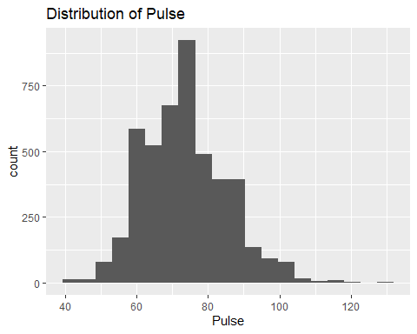
#QQPlot
qqnorm(NHANES_mod$Pulse)
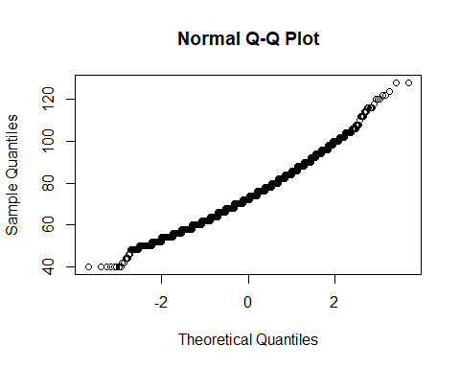
#Violin Plot
NHANES_mod %>%
filter (!is.na(Pulse)) %>%
ggplot(aes(x=as.factor(Relationship), y=Pulse,)) +
geom_violin() +
ggtitle("Distribution of Pulse by Relationship Type") +
ylab("Pulse") +
xlab("Relationship Type")
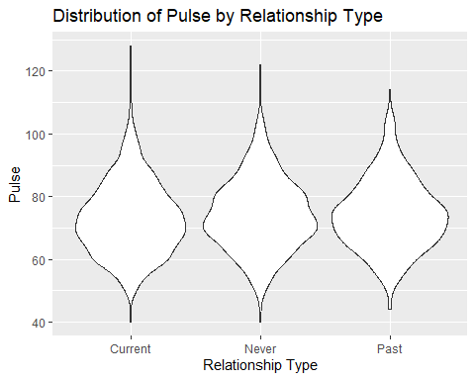
#Boxplot
NHANES_mod %>%
filter(!is.na(Pulse)) %>%
ggplot(aes(x = as.factor(Relationship), y = Pulse)) +
geom_boxplot() +
stat_summary(aes(color = "Mean"), fun = mean, geom = "point", shape = 20, size = 5) + # Mean point
scale_color_manual(name = "Legend", values = c("Mean" = "red")) +
ggtitle("Distribution of Pulse by Relationship Type") +
ylab("Pulse") +
xlab("Relationship Type")
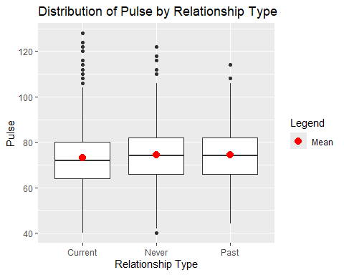
#Violin Plot
NHANES_mod %>%
filter (!is.na(Pulse)) %>%
ggplot(aes(x=as.factor(MaritalStatus), y=Pulse,)) +
geom_violin() +
ggtitle("Distribution of Pulse by Marital Status") +
ylab("Pulse") +
xlab("Marital Status")
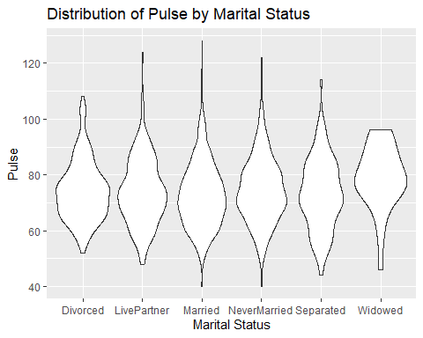
#Boxplot
NHANES_mod %>%
filter(!is.na(Pulse)) %>%
ggplot(aes(x = as.factor(MaritalStatus), y = Pulse)) +
geom_boxplot() +
stat_summary(aes(color = "Mean"), fun = mean, geom = "point", shape = 20, size = 5) + # Mean point
scale_color_manual(name = "Legend", values = c("Mean" = "red")) +
ggtitle("Distribution of Pulse by Marital Status") +
ylab("Pulse") +
xlab("Marital Status")
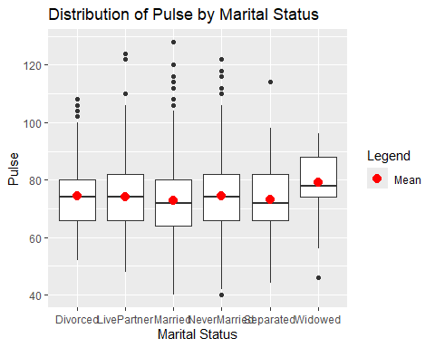
This histogram and QQ plot show that the pulse rate data is normally distributed, satisfying the assumption made by many statistical tests. The relationship types also show a normal distribution, as evidenced by the violin plot of the pulse by relationship type. Once separated into the marital statuses individually, the violin plot shows they are also approximately normally distributed. A small amount of skewedness could be argued, but since the sample size of all groups are large enough, this is acceptable for many tests. The box plots show that while there may not be a large difference between the relationship types in terms of the mean, both the mean and median of the widows’ pulse rate is higher than those of the other marital statuses, as is the IQR. This supports the idea that widows may experience higher heart rate on average, meaning that marital status may be able to provide insight into pulse rate.

Blood Pressure

Pulse Pressure
#Histograms
NHANES_modBP %>%
filter (!is.na(PulsePressure)) %>%
ggplot(aes(x = PulsePressure)) +
geom_histogram(bins=25) +
ggtitle("Distribution of Pulse Pressure") +
xlab("Average Pulse Pressure")
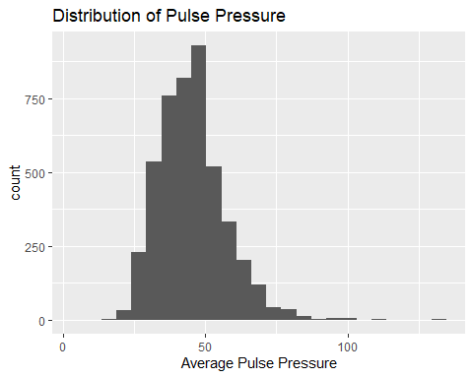
#QQPlot
qqnorm(NHANES_modBP$PulsePressure)
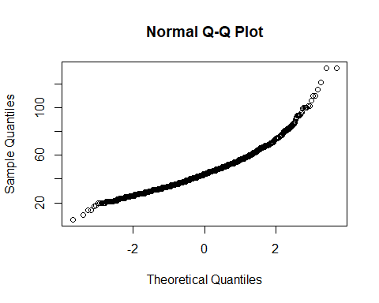
NHANES_modBP %>%
filter (!is.na(PulsePressure)) %>%
ggplot(aes(x = log(PulsePressure))) +
geom_histogram(bins=25) +
ggtitle("Distribution of log-transformed Pulse Pressure") +
xlab("Average Pulse Pressure")
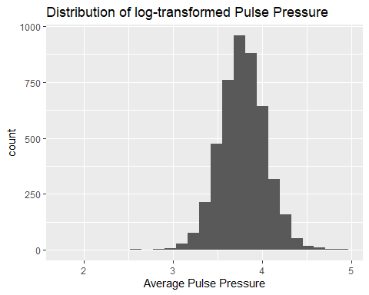
NHANES_modBP <- NHANES_modBP %>%
mutate(logPP = log(PulsePressure))
NHANES_mod <- NHANES_mod %>%
mutate(logPP = log(PulsePressure))
#Violin Plot
NHANES_modBP %>%
filter (!is.na(PulsePressure)) %>%
ggplot(aes(x=as.factor(Relationship), y=logPP)) +
geom_violin() +
ggtitle("Distribution of log-transformed Pulse Pressure \n by Relationship Type") +
ylab("log-transformed Pulse Pressure") +
xlab("Relationship Type")
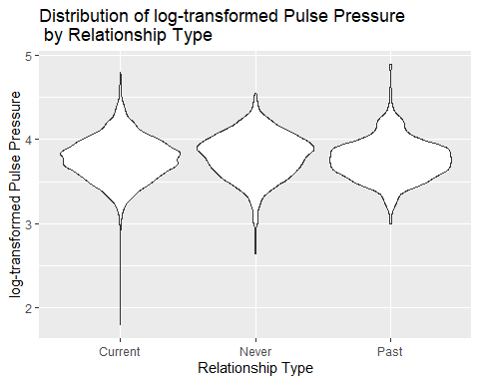
#Boxplot
NHANES_modBP %>%
filter (!is.na(PulsePressure)) %>%
ggplot(aes(x=as.factor(Relationship), y=logPP)) +
geom_boxplot() +
ggtitle("Distribution of log-transformed Pulse Pressure \n by Relationship Type") +
stat_summary(aes(color = "Mean"), fun = mean, geom = "point", shape = 20, size = 5) + # Mean point
scale_color_manual(name = "Legend", values = c("Mean" = "red")) +
ylab("log-transformed Pulse Pressure") +
xlab("Relationship Type")
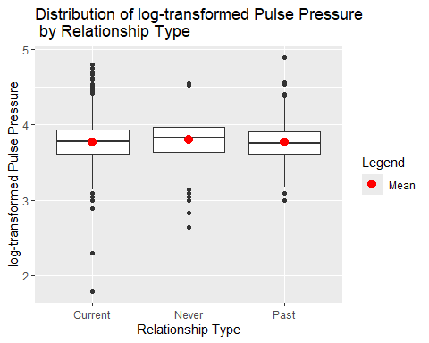
#Violin Plot
NHANES_modBP %>%
filter (!is.na(PulsePressure)) %>%
ggplot(aes(x=as.factor(MaritalStatus), y=logPP)) +
geom_violin() +
ggtitle("Distribution of log-transformed Pulse Pressure \n by Marital Status") +
ylab("log-transformed Pulse Pressure") +
xlab("Marital Status")
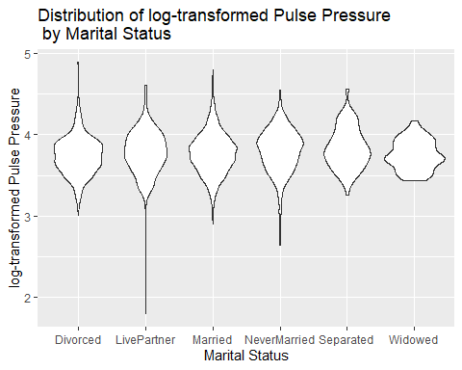
#Boxplot
NHANES_modBP %>%
filter (!is.na(PulsePressure)) %>%
ggplot(aes(x=as.factor(MaritalStatus), y=logPP)) +
geom_boxplot() +
ggtitle("Distribution of log-transformed Pulse Pressure \n by Marital Status") +
stat_summary(aes(color = "Mean"), fun = mean, geom = "point", shape = 20, size = 5) + # Mean point
scale_color_manual(name = "Legend", values = c("Mean" = "red")) +
ylab("log-transformed Pulse Pressure") +
xlab("Marital Status")
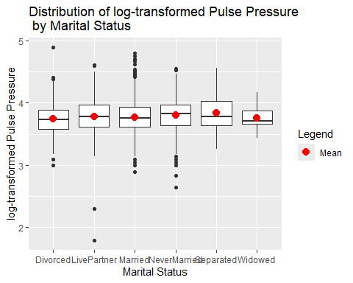
The histogram and QQ plot for the Pulse pressure do show there is more skewedness than the pulse, but since the sample size is large, this amount of skewedness could be considered acceptable for most statistical tests. However, this is easily be corrected using the log-transformed of Pulse Pressure, which is presented in the second histogram. Considering this, the remaining plots for pulse pressure utilize the log-transformed Pulse Pressure, stored in the variable “logPP” in the data set.
After the logarithmic correction, the violin plots showing marital status or relationship type show minimal to no skew in the data. The box plots represent the data as generally being equal, since the IQRs are all overlapping and occupying the same values. This is interesting considering one of the main indicators of Takotsubo cardiomyopathy is a narrow or low pulse pressure, suggesting that the prediction I had will be incorrect for this variable. The mean for widows may be slightly lower, albeit not as dramatic of a difference as seen in the pulse rate. This plot also shows that there may be outliers in the LivePartner group, with two points that are rather low. However, since these are not as extreme as the 0 values found earlier in the diastolic blood pressure values, I will be leaving these in the data set and not filtering them out during analysis. There are quite a few outliers that are high as well, particularly in married and divorced individuals, which should be kept in mind during analysis interpretation.

Systolic Blood Pressure
#Histogram
NHANES_mod %>%
filter (!is.na(BPSysAve)) %>%
ggplot(aes(x = BPSysAve)) +
geom_histogram(bins=25) +
ggtitle("Distribution of Average Systolic Blood Pressure") +
xlab("Average Systolic Blood Pressure")
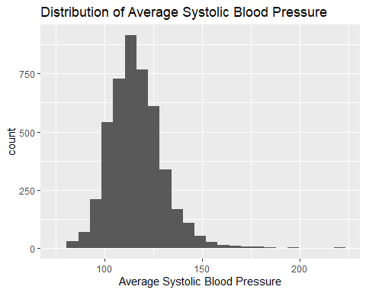
#QQPlot
qqnorm(NHANES_mod$BPSysAve)
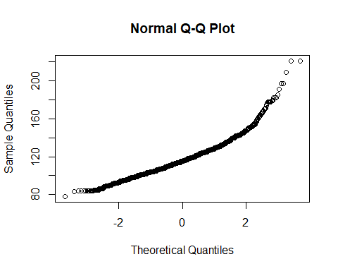
#Violin Plot
NHANES_mod %>%
filter (!is.na(BPSysAve)) %>%
ggplot(aes(x=as.factor(Relationship), y=BPSysAve)) +
geom_violin() +
ggtitle("Distribution of Average Systolic Blood Pressure \n by Relationship Type") +
ylab("Average Systolic Blood Pressure") +
xlab("Relationship Type")
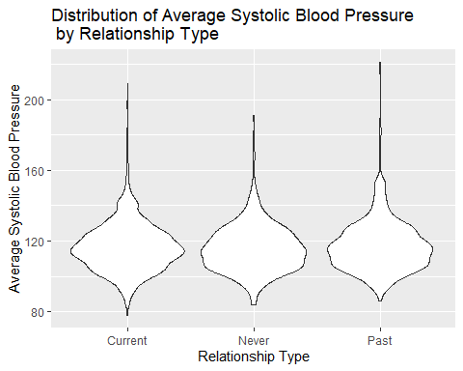
#Boxplot
NHANES_mod %>%
filter (!is.na(BPSysAve)) %>%
ggplot(aes(x=as.factor(Relationship), y=BPSysAve)) +
geom_boxplot() +
stat_summary(aes(color = "Mean"), fun = mean, geom = "point", shape = 20, size = 5) + # Mean point
scale_color_manual(name = "Legend", values = c("Mean" = "red")) +
ggtitle("Distribution of Average Systolic Blood Pressure \n by Relationship Type") +
ylab("Average Systolic Blood Pressure") +
xlab("Relationship Type")
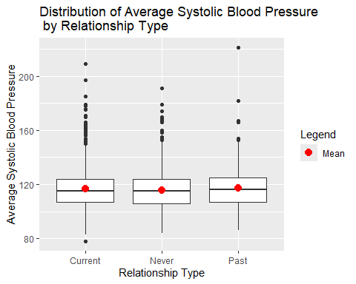
#Violin Plot
NHANES_mod %>%
filter (!is.na(BPSysAve)) %>%
ggplot(aes(x=as.factor(MaritalStatus), y=BPSysAve)) +
geom_violin() +
ggtitle("Distribution of Average Systolic Blood Pressure \n by Marital Status") +
ylab("Average Systolic Blood Pressure") +
xlab("Marital Status")
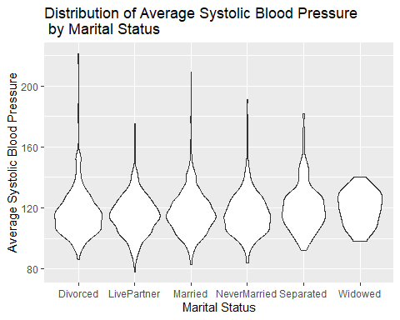
#Boxplot
NHANES_mod %>%
filter (!is.na(BPSysAve)) %>%
ggplot(aes(x=as.factor(MaritalStatus), y=BPSysAve)) +
geom_boxplot() +
stat_summary(aes(color = "Mean"), fun = mean, geom = "point", shape = 20, size = 5) + # Mean point
scale_color_manual(name = "Legend", values = c("Mean" = "red")) +
ggtitle("Distribution of Average Systolic Blood Pressure \n by Marital Status") +
ylab("Average Systolic Blood Pressure") +
xlab("Marital Status")
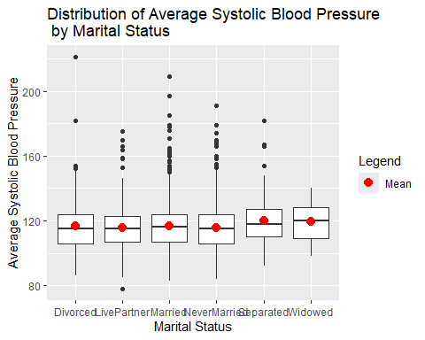
All plots that are for displaying skewedness in the data show that the systolic blood pressure, across the whole data set and when divided by relationship type and marital status, are approximately normally distributed. This variable is not skewed enough to warrant the transformation of the data before analysis. There may be the presence of outliers, as can be noted in the box plots. There are points that lie far above the IQR and whiskers for those all categories for relationship, but they mainly reside in married and never married when dissecting further. There is one point in the divorced data that lies above 200mmHg that is not surrounded by other points, suggesting it could be true outlier or the result of measurement error. Again, it appears there is not a large difference in IQR between the categories in the box plot, despite the mean showing variation in the summary statistics. Graphing the data shows that there may not be as large of a difference as originally perceived when viewing the numbers on their own. Viewing this box plot suggests that marital status cannot be used to predict systolic blood pressure.

Diastolic Blood Pressure
#Histogram
NHANES_modBP %>%
filter (!is.na(BPDiaAve)) %>%
ggplot(aes(x = BPDiaAve)) +
geom_histogram(bins=25) +
ggtitle("Distribution of Average Diastolic Blood Pressure") +
xlab("Average Diastolic Blood Pressure")
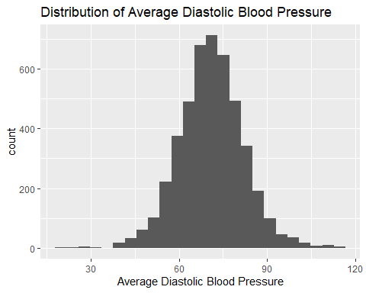
#QQPlot
qqnorm(NHANES_modBP$BPDiaAve)
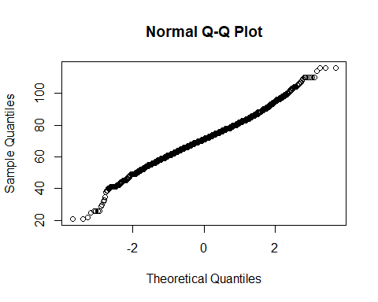
#Violin Plot
NHANES_modBP %>%
filter (!is.na(BPDiaAve)) %>%
ggplot(aes(x=as.factor(Relationship), y=BPDiaAve)) +
geom_violin() +
ggtitle("Distribution of Average Diastolic Blood Pressure \n by Relationship Type") +
ylab("Average Diastolic Blood Pressure") +
xlab("Relationship Type")
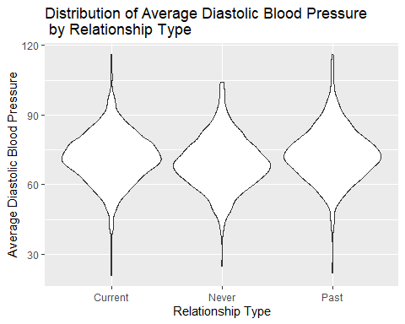
#Boxplot
NHANES_modBP %>%
filter (!is.na(BPDiaAve)) %>%
ggplot(aes(x=as.factor(Relationship), y=BPDiaAve)) +
geom_boxplot() +
stat_summary(aes(color = "Mean"), fun = mean, geom = "point", shape = 20, size = 5) + # Mean point
scale_color_manual(name = "Legend", values = c("Mean" = "red")) +
ggtitle("Distribution of Average Diastolic Blood Pressure \n by Relationship Type") +
ylab("Average Diastolic Blood Pressure") +
xlab("Relationship Type")
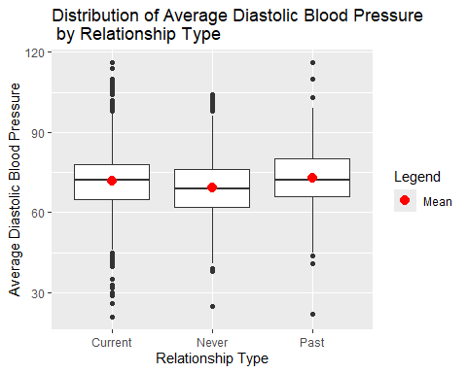
#Violin Plot
NHANES_modBP %>%
filter (!is.na(BPDiaAve)) %>%
ggplot(aes(x=as.factor(MaritalStatus), y=BPDiaAve)) +
geom_violin() +
ggtitle("Distribution of Average Diastolic Blood Pressure \n by Marital Status") +
ylab("Average Diastolic Blood Pressure") +
xlab("Marital Status")
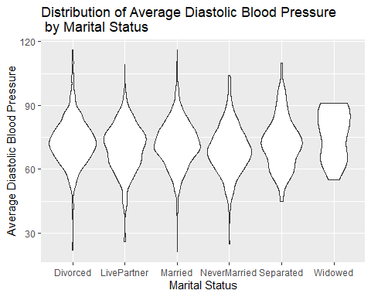
#Boxplot
NHANES_modBP %>%
filter (!is.na(BPDiaAve)) %>%
ggplot(aes(x=as.factor(MaritalStatus), y=BPDiaAve)) +
geom_boxplot() +
stat_summary(aes(color = "Mean"), fun = mean, geom = "point", shape = 20, size = 5) + # Mean point
scale_color_manual(name = "Legend", values = c("Mean" = "red")) +
ggtitle("Distribution of Average Diastolic Blood Pressure \n by Marital Status") +
ylab("Average Diastolic Blood Pressure") +
xlab("Marital Status")
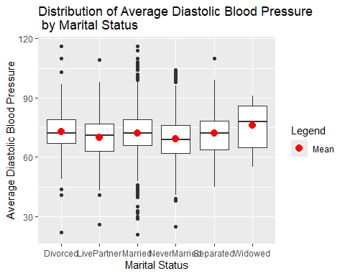
The histogram, QQ Plot, and violin plots do not show major skewedness, neither in the broad categories of relationship type nor the specific categories of marital status. The box plots reveal more information; there is a notable difference in the appearance of the data when separated by relationship versus by marital status. When separated by relationship type, there doesn’t appear to be a major difference in the spread via the IQR, though there may be a slight difference in means. However, marital status reveals more variability in means than was seen with the previous two blood pressure variables, which goes against my prediction that they will be closely related in terms of if one shows predictability, so will the others. This box plot suggests that the widows have a higher average diastolic blood pressure, and that the never married group on average has a lower average diastolic blood pressure. Although this does not match my prediction that widows may have lower blood pressure, it does suggest that average diastolic blood pressure could be linked to marital status.

Cholesterol

Total Cholesterol
#Histogram
NHANES_mod %>%
filter (!is.na(TotChol)) %>%
ggplot(aes(x = TotChol)) +
geom_histogram(bins=25) +
ggtitle("Distribution of Total Cholesterol Level") +
xlab("Total Cholesterol Level")
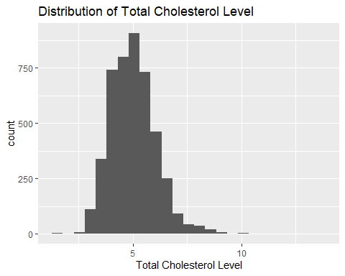
#QQPlot
qqnorm(NHANES_mod$TotChol)
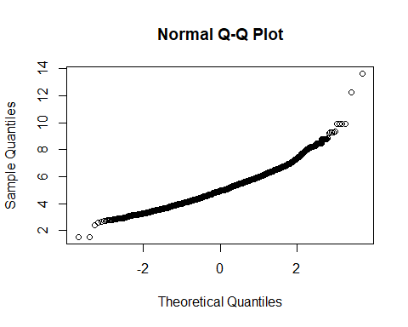
#Violin Plot
NHANES_mod %>%
filter (!is.na(TotChol)) %>%
ggplot(aes(x=as.factor(Relationship), y=TotChol)) +
geom_violin() +
ggtitle("Distribution of Total Cholesterol by Relationship Type") +
ylab("Total Cholesterol") +
xlab("Relationship Type")
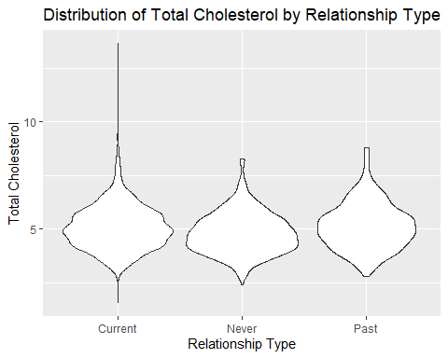
#Boxplot
NHANES_mod %>%
filter (!is.na(TotChol)) %>%
ggplot(aes(x=as.factor(Relationship), y=TotChol)) +
geom_boxplot() +
stat_summary(aes(color = "Mean"), fun = mean, geom = "point", shape = 20, size = 5) + # Mean point
scale_color_manual(name = "Legend", values = c("Mean" = "red")) +
ggtitle("Distribution of Total Cholesterol by Relationship Type") +
ylab("Total Cholesterol") +
xlab("Relationship Type")
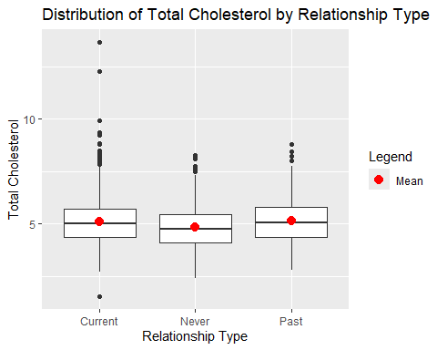
#Violin Plot
NHANES_mod %>%
filter (!is.na(TotChol)) %>%
ggplot(aes(x=as.factor(MaritalStatus), y=TotChol)) +
geom_violin() +
ggtitle("Distribution of Total Cholesterol by Marital Status") +
ylab("Total Cholesterol") +
xlab("Marital Status")
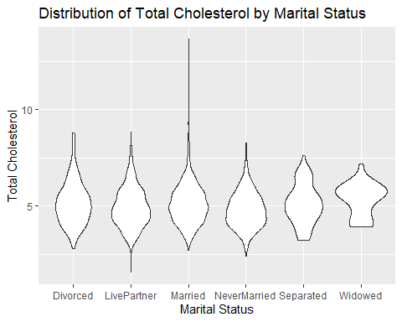
#Boxplot
NHANES_mod %>%
filter (!is.na(TotChol)) %>%
ggplot(aes(x=as.factor(MaritalStatus), y=TotChol)) +
geom_boxplot() +
stat_summary(aes(color = "Mean"), fun = mean, geom = "point", shape = 20, size = 5) + # Mean point
scale_color_manual(name = "Legend", values = c("Mean" = "red")) +
ggtitle("Distribution of Total Cholesterol by Marital Status") +
ylab("Total Cholesterol") +
xlab("Marital Status")
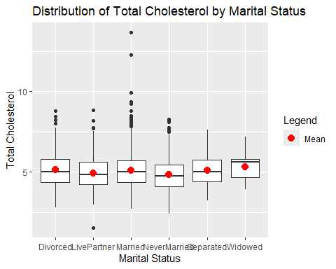
Generally, total cholesterol is normally distributed for the whole data set when viewing the histogram and QQ plot, and any amount of non-normality seen in the violin plots are minor enough that the sample size allows for normal statistical analysis for most of the groups. The IQR and means visible in the first box plot suggest that there may not be a significant difference between the relationship types. However, once further divided into marital status in the second box plot, it becomes apparent that the median of the widowed group is clearly greater than those in the other groups. Perhaps, this method of central tendency should be examined here as well, especially when reviewing the violin plot and noting the peak for the widowed group is further right skewed than the rest of the other categories. It may be prudent to use a different statistical method for this variable investigation given the stark difference between the mean and median for widows. The widows being higher in cholesterol levels here goes against my original prediction, but again, suggests that there could be a relationship between marital status and total cholesterol.

Direct Cholesterol
#Histogram
NHANES_mod %>%
filter (!is.na(DirectChol)) %>%
ggplot(aes(x = DirectChol)) +
geom_histogram(bins=25) +
ggtitle("Distribution of Direct Cholesterol Level") +
xlab("Direct Cholesterol Level")
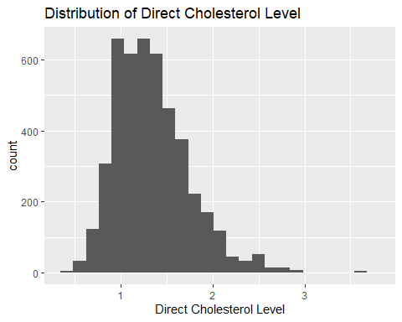
#QQPlot
qqnorm(NHANES_mod$DirectChol)
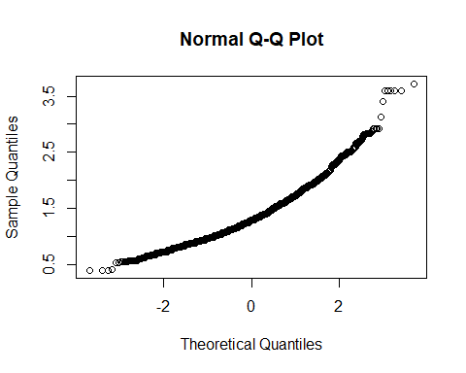
NHANES_mod %>%
filter (!is.na(DirectChol)) %>%
ggplot(aes(x = log(DirectChol))) +
geom_histogram(bins=25) +
ggtitle("Distribution of Direct Cholesterol Level") +
xlab("Direct Cholesterol Level")
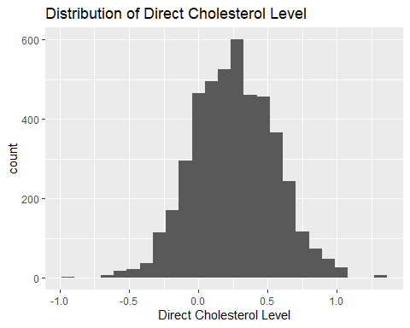
NHANES_mod <- NHANES_mod %>%
mutate(logDC = log(DirectChol))
#Violin Plot
NHANES_mod %>%
filter (!is.na(DirectChol)) %>%
ggplot(aes(x=as.factor(Relationship), y=DirectChol)) +
geom_violin() +
ggtitle("Distribution of Direct Cholesterol by Relationship Type") +
ylab("Direct Choleserol") +
xlab("Relationship Type")
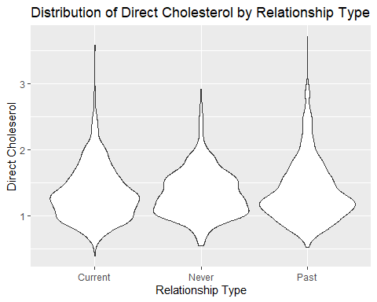
NHANES_mod %>%
filter (!is.na(DirectChol)) %>%
ggplot(aes(x=as.factor(Relationship), y=logDC)) +
geom_violin() +
ggtitle("Distribution of log-transformed Direct Cholesterol \n by Relationship Type") +
ylab("log-transformed Direct Choleserol") +
xlab("Relationship Type")
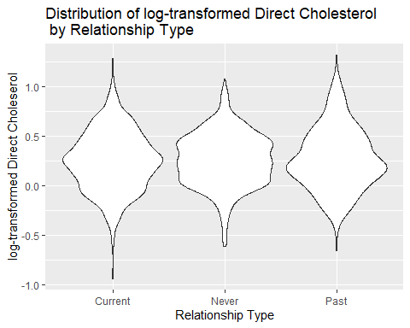
#Boxplot
NHANES_mod %>%
filter (!is.na(DirectChol)) %>%
ggplot(aes(x=as.factor(Relationship), y=logDC)) +
geom_boxplot() +
stat_summary(aes(color = "Mean"), fun = mean, geom = "point", shape = 20, size = 5) + # Mean point
scale_color_manual(name = "Legend", values = c("Mean" = "red")) +
ggtitle("Distribution of log-transformed Direct Cholesterol \n by Relationship Type") +
ylab("log-transformed Direct Choleserol") +
xlab("Relationship")
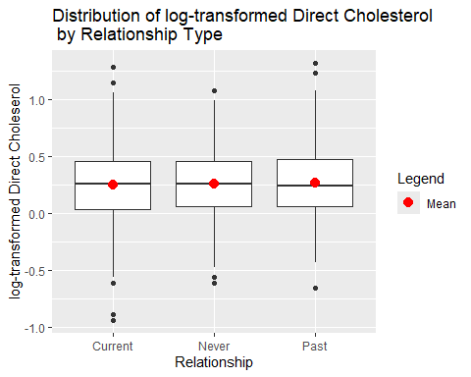
#Violin Plot
NHANES_mod %>%
filter (!is.na(DirectChol)) %>%
ggplot(aes(x=as.factor(MaritalStatus), y=logDC)) +
geom_violin() +
ggtitle("Distribution of log-transformed Direct Cholesterol \n by Marital Status") +
ylab("log-transformed Direct Choleserol") +
xlab("Marital Status")
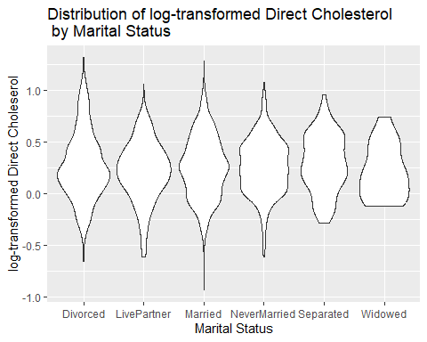
#Boxplot
NHANES_mod %>%
filter (!is.na(DirectChol)) %>%
ggplot(aes(x=as.factor(MaritalStatus), y=logDC)) +
geom_boxplot() +
stat_summary(aes(color = "Mean"), fun = mean, geom = "point", shape = 20, size = 5) + # Mean point
scale_color_manual(name = "Legend", values = c("Mean" = "red")) +
ggtitle("Distribution of log-transformed Direct Cholesterol \n by Marital Status") +
ylab("log-transformed Direct Choleserol") +
xlab("Marital Status")
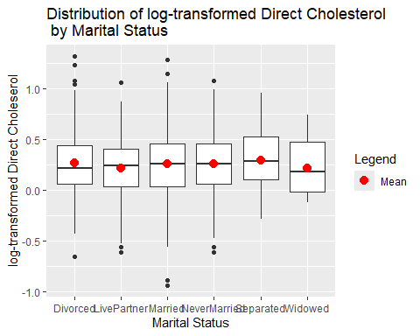
Despite the approximately normally distributed histogram and QQ plot, the first violin plot of relationship type versus direct cholesterol levels show that there is a more significant right skew to the direct cholesterol data. This has been corrected for bytransforming the direct cholesterol with a log function and saving it in a new variable called “logDC”. Any further analysis and graphs have been made with this log-transformed direct cholesterol measurements. The box plots, again, show differences in how the variable changes with the relationship type and marital status categories. In the relationship types, it appears as though there is minimal difference in means or in the IQR and spread. However, upon further division into marital statuses, it shows that there may be an effect of being widowed in comparison to the other statuses, for both the median and the mean. This supports my original prediction that the cholesterol levels may be lower for this group, and may suggest a small amount of predictability for this variable based on marital status, but not on a broader relationship types.

Analysis
Since there is one categorical with more than two groups being compared across multiple variables, several ANOVA tests will be conducted to determine if there is a difference in means. This will be conducted first for the general relationship types to find if having never been in a recordable relationship, having one in the past and lost it, or currently being in one can influence these predictors of heart health. This will then be further subdivided into the marital status groups to more closely analyze where significance, if any, may stem from. Since there are so many variables being analyzed, a Tukey’s Honest Significant Difference (HSD) test is also performed for each.

Pulse Rate
pr <- NHANES_mod %>%
filter(!is.na(Pulse))
pr_ANOVA2 <- aov(Pulse ~ Relationship, data = pr)
summary(pr_ANOVA2)
Df Sum Sq Mean Sq F value Pr(>F)
Relationship 2 1661 830.5 6.01 0.00247 **
Residuals 4607 636619 138.2
---
Signif. codes: 0 '***' 0.001 '**' 0.01 '*' 0.05 '.' 0.1 ' ' 1
TukeyHSD(pr_ANOVA2, conf.level=.95)
Tukey multiple comparisons of means
95% family-wise confidence level
Fit: aov(formula = Pulse ~ Relationship, data = pr)
$Relationship
diff lwr upr p adj
Never-Current 1.22489510 0.27444812 2.175342 0.0071382
Past-Current 1.25662383 -0.00889919 2.522147 0.0521208
Past-Never 0.03172873 -1.37237853 1.435836 0.9984538
The ANOVA table above, with a p-value of 0.0025, the null hypothesis that there is no difference in pulse rate between relationship types is rejected at a 95% and a 99% confidence level. Utilizing the Tukey’s HSD test, this can be further broken down into the following for a 5% significance level:
- With a p-value of 0.0071 and a 95% confidence interval of 0.27 to 2.17, the null hypothesis is rejected for this family-wise pair; there is a difference in pulse rate between Never and Current in the Relationship variable for those aged 20 to 55 years. Those that belong to the Never category, on average, have a pulse rate 1.22BPM higher than those belonging to the Current category.
- With a p-value of 0.0521, there is no difference in pulse rate between Past and Current in the Relationship variable in those aged 20 to 55 years, meaning the null hypothesis has failed to be rejected for this family-wise pair.
- With a p-value of 0.9984, here is no difference in pulse rate between Past and Never in the Relationship variable in those aged 20 to 55 years, meaning the null hypothesis has failed to be rejected for this family-wise pair.
To gain more insight, this can be further divided into Marital Statuses to see which specific pairs are contributing to the above, broader interpretation.
pr_ANOVA <- aov(Pulse ~ MaritalStatus, data = pr)
summary(pr_ANOVA)
Df Sum Sq Mean Sq F value Pr(>F)
MaritalStatus 5 3068 613.7 4.448 0.000481 ***
Residuals 4604 635212 138.0
---
Signif. codes: 0 '***' 0.001 '**' 0.01 '*' 0.05 '.' 0.1 ' ' 1
TukeyHSD(pr_ANOVA, conf.level=.95)
Tukey multiple comparisons of means
95% family-wise confidence level
Fit: aov(formula = Pulse ~ MaritalStatus, data = pr)
$MaritalStatus
diff lwr upr p adj
LivePartner-Divorced -0.31904392 -2.6025431 1.9644552 0.9987129
Married-Divorced -1.41983310 -3.2153882 0.3757220 0.2133287
NeverMarried-Divorced -0.01868805 -1.9409725 1.9035964 1.0000000
Separated-Divorced -1.17440908 -4.5579031 2.2090849 0.9214237
Widowed-Divorced 4.81572482 -1.2453165 10.8767661 0.2086721
Married-LivePartner -1.10078918 -2.8119155 0.6103371 0.4437914
NeverMarried-LivePartner 0.30035588 -1.5433123 2.1440241 0.9973114
Separated-LivePartner -0.85536516 -4.1948212 2.4840909 0.9782505
Widowed-LivePartner 5.13476874 -0.9017995 11.1713370 0.1477617
NeverMarried-Married 1.40114506 0.2142322 2.5880580 0.0100118
Separated-Married 0.24542402 -2.7813922 3.2722403 0.9999102
Widowed-Married 6.23555792 0.3661622 12.1049537 0.0297232
Separated-NeverMarried -1.15572103 -4.2593924 1.9479503 0.8965273
Widowed-NeverMarried 4.83441286 -1.0749835 10.7438092 0.1812722
Widowed-Separated 5.99013390 -0.5423863 12.5226541 0.0939839
In the above 15 comparisons, two pairs reject the null hypothesis at a 5% significance level.
- With a p-value of 0.0100, there is a difference in pulse rate between NeverMarried and Married in the MaritalStatus variable, with a 95% confidence interval of 0.21 BPM to 2.59 BPM. Those that were never married, on average, have a pulse rate 1.40BPM higher than those that are married for those aged 20 to 55 years.
- With a p-value of 0.0297, there is a difference in pulse rate between Never and Current in the Relationship variable, with a 95% confidence interval of 0.37 BPM to 12.10 BPM. Between the ages of 20 and 55 years, widows on average have a pulse rate 6.23 BPM higher than those that are married.
All other comparisons fail to reject the null hypothesis at a 5% significance level, meaning we cannot conclude from this data that the pulse rate changes based on those pair comparisons for individuals aged 20 to 55 years.

Blood Pressure

Pulse Pressure
pp <- NHANES_mod %>%
filter(BPDiaAve != 0) %>%
filter(!is.na(PulsePressure))
pp_ANOVA2 <- aov(logPP ~ Relationship, data = pp)
summary(pp_ANOVA2)
Df Sum Sq Mean Sq F value Pr(>F)
Relationship 2 1.18 0.5898 8.798 0.000154 ***
Residuals 4599 308.32 0.0670
---
Signif. codes: 0 '***' 0.001 '**' 0.01 '*' 0.05 '.' 0.1 ' ' 1
TukeyHSD(pp_ANOVA2, conf.level=.95)
Tukey multiple comparisons of means
95% family-wise confidence level
Fit: aov(formula = logPP ~ Relationship, data = pp)
$Relationship
diff lwr upr p adj
Never-Current 0.035020042 0.01406749 0.05597259 0.0002664
Past-Current -0.007028755 -0.03492794 0.02087043 0.8251491
Past-Never -0.042048797 -0.07300275 -0.01109484 0.0041630
The ANOVA table above, with a p-value of 0.0002, the null hypothesis is rejected at a 95% and a 99% confidence level, meaning that there is a difference in the log-transformed average pulse pressure with relationship type. Utilizing the Tukey’s HSD test, this can be further broken down into the following at a 5% significance level:
- With a p-value of 0.0003 and a 95% confidence interval of 0.01 to 0.06, there is a difference in the log-transformed average pulse pressure between Never and Current in the Relationship variable. The null hypothesis is rejected for this family-wise pair. Those that belong to the Never category and are between 20 and 55 years old, on average, have a log-transformed pulse pressure that is 0.035 higher than those belonging to the Current category.
- With a p-value of 0.8251, there is no difference in the log-transformed pulse pressure between Past and Current in the Relationship variable for those aged 20 to 55 years, meaning the null hypothesis has failed to be rejected for this family-wise pair.
- With a p-value of 0.0042, there is a difference in the log-transformed average pulse pressure between Past and Never in the Relationship variable for those aged 20 to 55 years, with a 95% confidence interval of -0.07 to -0.01, meaning the null hypothesis is rejected for this family-wise pair. Those that belong to the Past category, on average, have a log-transformed average pulse pressure that is 0.04 lower than those belonging to the Never category.
This can be further divided into Marital Statuses to see which specific pairs are contributing to this broad interpretation.
pp_ANOVA <- aov(logPP ~ MaritalStatus, data = pp)
summary(pp_ANOVA)
Df Sum Sq Mean Sq F value Pr(>F)
MaritalStatus 5 2.08 0.4156 6.213 9.48e-06 ***
Residuals 4596 307.42 0.0669
---
Signif. codes: 0 '***' 0.001 '**' 0.01 '*' 0.05 '.' 0.1 ' ' 1
TukeyHSD(pp_ANOVA, conf.level=.95)
Tukey multiple comparisons of means
95% family-wise confidence level
Fit: aov(formula = logPP ~ MaritalStatus, data = pp)
$MaritalStatus
diff lwr upr p adj
LivePartner-Divorced 0.039367257 -0.0109640496 0.08969856 0.2241372
Married-Divorced 0.026290029 -0.0132489153 0.06582897 0.4048947
NeverMarried-Divorced 0.063398379 0.0210636229 0.10573314 0.0002885
Separated-Divorced 0.092239067 0.0175191357 0.16695900 0.0058300
Widowed-Divorced 0.009695826 -0.1237588898 0.14315054 0.9999478
Married-LivePartner -0.013077229 -0.0508269880 0.02467253 0.9220360
NeverMarried-LivePartner 0.024031122 -0.0166376355 0.06469988 0.5420757
Separated-LivePartner 0.052871810 -0.0209169723 0.12666059 0.3181865
Widowed-LivePartner -0.029671431 -0.1626070449 0.10326418 0.9882905
NeverMarried-Married 0.037108351 0.0109542784 0.06326242 0.0007550
Separated-Married 0.065949038 -0.0009454459 0.13284352 0.0559489
Widowed-Married -0.016594203 -0.1458302853 0.11264188 0.9991447
Separated-NeverMarried 0.028840688 -0.0397433885 0.09742476 0.8376000
Widowed-NeverMarried -0.053702553 -0.1838212242 0.07641612 0.8481360
Widowed-Separated -0.082543241 -0.2264935970 0.06140712 0.5753964
In the above 15 comparisons, three pairs reject the null hypothesis at a 5% significance level.
- With a p-value of 0.0003 and a 95% confidence interval of 0.02 to 0.11, there is a difference in the log-transformed average pulse pressure between NeverMarried and Divorced in the MaritalStatus variable. Those that belong to the NeverMarried category, on average, have a log-transformed pulse pressure that is 0.063 higher than those belonging to the Divorced category for those aged 20 to 55 years.
- In individuals between 20 and 55 years, with a p-value of 0.0058 and a 95% confidence interval of 0.02 to 0.17, there is a difference in the log-transformed average pulse pressure between Separated and Divorced in the MaritalStatus variable. Those that belong to the Separated category, on average, have a pulse pressure that is 0.092 higher than those belonging to the Divorced category.
- With a p-value of 0.0008 and a 95% confidence interval of 0.01 to 0.06, there is a difference in the log-transformed average pulse pressure between NeverMarried and Married in the MaritalStatus variable for those aged 20 to 55 years. Those that belong to the NeverMarried category, on average, have a log-transformed pulse pressure that is 0.037 higher than those belonging to the Married category.
All other comparisons fail to reject the null hypothesis at a 5% significance level, meaning we cannot conclude from this data that the log-transformed average pulse pressure changes based on those pair comparisons for individuals aged 20 to 55 years.

Systolic Blood Pressure
sbp <- NHANES_mod %>%
filter(!is.na(BPSysAve))
sbp_ANOVA2 <- aov(BPSysAve ~ Relationship, data = sbp)
summary(sbp_ANOVA2)
Df Sum Sq Mean Sq F value Pr(>F)
Relationship 2 1213 606.3 3.166 0.0423 *
Residuals 4603 881365 191.5
---
Signif. codes: 0 '***' 0.001 '**' 0.01 '*' 0.05 '.' 0.1 ' ' 1
TukeyHSD(sbp_ANOVA2, conf.level=.95)
Tukey multiple comparisons of means
95% family-wise confidence level
Fit: aov(formula = BPSysAve ~ Relationship, data = sbp)
$Relationship
diff lwr upr p adj
Never-Current -0.8071973 -1.92644954 0.3120549 0.2087850
Past-Current 0.9174577 -0.57341492 2.4083302 0.3190545
Past-Never 1.7246550 0.07062101 3.3786889 0.0386198
The ANOVA table above, with a p-value of 0.04, the null hypothesis is rejected at a 95% confidence level, meaning that there is a difference in the average systolic blood pressure with relationship type. Utilizing the Tukey’s HSD test, this can be further broken down into the following at a 5% significance level:
- With a p-value of 0.0386 and a 95% confidence interval of 0.07mmHg to 3.38mmHg, for those aged 20 to 55 years there is a difference in average systolic blood pressure between Past and Never in the Relationship variable. The null hypothesis is rejected for this family-wise pair. Those that belong to the Past category, on average, have an average systolic blood pressure that is 1.72mmHg higher than those belonging to the Current category.
- With a p-value of 0.2088, there is no difference in average systolic blood pressure between Never and Current in the Relationship variable for individuals aged 20 to 55 years, meaning the null hypothesis has failed to be rejected for this family-wise pair.
- With a p-value of 0.3191, there is no difference in average systolic blood pressure between Past and Current in the Relationship variable for those aged 20 to 55 years, meaning the null hypothesis has failed to be rejected for this family-wise pair.
This can be further divided into Marital Statuses to see which specific pairs are contributing to this broad interpretation.
sbp_ANOVA <- aov(BPSysAve ~ MaritalStatus, data = sbp)
summary(sbp_ANOVA)
Df Sum Sq Mean Sq F value Pr(>F)
MaritalStatus 5 3094 618.8 3.236 0.0064 **
Residuals 4600 879484 191.2
---
Signif. codes: 0 '***' 0.001 '**' 0.01 '*' 0.05 '.' 0.1 ' ' 1
TukeyHSD(sbp_ANOVA, conf.level=.95)
Tukey multiple comparisons of means
95% family-wise confidence level
Fit: aov(formula = BPSysAve ~ MaritalStatus, data = sbp)
$MaritalStatus
diff lwr upr p adj
LivePartner-Divorced -0.9865702 -3.6760555 1.7029151 0.9023521
Married-Divorced 0.2311042 -1.8826541 2.3448624 0.9996093
NeverMarried-Divorced -0.7707670 -3.0338858 1.4923517 0.9271688
Separated-Divorced 3.4788659 -0.5159166 7.4736485 0.1293570
Widowed-Divorced 2.9246519 -4.2102927 10.0595966 0.8518482
Married-LivePartner 1.2176743 -0.7985572 3.2339059 0.5173009
NeverMarried-LivePartner 0.2158032 -1.9565049 2.3881112 0.9997558
Separated-LivePartner 4.4654361 0.5213895 8.4094827 0.0158757
Widowed-LivePartner 3.9112221 -3.1954403 11.0178846 0.6191435
NeverMarried-Married -1.0018712 -2.3995711 0.3958287 0.3177590
Separated-Married 3.2477618 -0.3285696 6.8240932 0.1000966
Widowed-Married 2.6935478 -4.2158150 9.6029105 0.8768653
Separated-NeverMarried 4.2496330 0.5830434 7.9162225 0.0123234
Widowed-NeverMarried 3.6954190 -3.2610907 10.6519286 0.6549523
Widowed-Separated -0.5542140 -8.2502915 7.1418634 0.9999501
In the above 15 comparisons, only two pairs reject the null hypothesis at a 5% significance level in individuals aged between 20 and 55 years.
- With a p-value of 0.0159 and a 95% confidence interval of 0.52mmHg to 8.41mmHg, there is a difference in average systolic blood pressure between Separated and LivePartner in the MaritalStatus variable. For those between 20 and 55 years old, if they are separated from their partner, on average they have an average systolic blood pressure that is 4.47mmHg higher than those that live with their partner.
- In individuals between 20 and 55 years, with a p-value of 0.0123 and a 95% confidence interval of 0.58mmHg to 7.92mmHg, there is a difference in average systolic blood pressure between Separated and NeverMarried in the MaritalStatus variable. Those that are separated, on average, have an average systolic blood pressure that is 4.25mmHg higher than those that have never been married.
All other comparisons fail to reject the null hypothesis at a 5% significance level, meaning we cannot conclude from this data that the average systolic blood pressure changes based on those pair comparisons for individuals aged 20 to 55 years.

Diastolic Blood Pressure
dbp <- NHANES_mod %>%
filter(BPDiaAve != 0) %>%
filter(!is.na(BPDiaAve))
dbp_ANOVA2 <- aov(BPDiaAve ~ Relationship, data = dbp)
summary(dbp_ANOVA2)
Df Sum Sq Mean Sq F value Pr(>F)
Relationship 2 6777 3389 27.57 1.26e-12 ***
Residuals 4599 565357 123
---
Signif. codes: 0 '***' 0.001 '**' 0.01 '*' 0.05 '.' 0.1 ' ' 1
TukeyHSD(dbp_ANOVA2, conf.level=.95)
Tukey multiple comparisons of means
95% family-wise confidence level
Fit: aov(formula = BPDiaAve ~ Relationship, data = dbp)
$Relationship
diff lwr upr p adj
Never-Current -2.354944 -3.2521588 -1.457730 0.0000000
Past-Current 1.369360 0.1746816 2.564038 0.0197826
Past-Never 3.724304 2.3988168 5.049791 0.0000000
The ANOVA table above provides a p-value of 1.26e-12, meaning the null hypothesis is rejected at most confidence levels. There is a difference in the average diastolic blood pressure with relationship type in those aged 20 to 55 years. Utilizing the Tukey’s HSD test, this can be further broken down into the following at a 5% significance level:
- With a p-value of 0.0000 and a 95% confidence interval of -3.25mmHg to -1.46mmHg, for those aged 20 to 55 years there is a difference in average diastolic blood pressure between Never and Current in the Relationship variable. The null hypothesis is rejected for this family-wise pair. Those having never been in a recordable relationship, on average, have an average diastolic blood pressure that is 2.35mmHg lower than those currently in a relationship.
- With a p-value of 0.0198 and a 95% confidence interval of 0.17mmHg to 2.56mmHg, for those aged 20 to 55 years there is a difference in average diastolic blood pressure between Past and Current in the Relationship variable. The null hypothesis is rejected for this family-wise pair. Those having had a past relationship, on average, have an average diastolic blood pressure that is 1.37mmHg higher than those currently in a relationship.
- With a p-value of 0.0000 and a 95% confidence interval of 2.40mmHg to 5.05mmHg, for those aged 20 to 55 years there is a difference in average diastolic blood pressure between Past and Never in the Relationship variable. The null hypothesis is rejected for this family-wise pair. Those having had a past relationship, on average, have an average diastolic blood pressure that is 3.72mmHg higher than those having never been in a recordable relationship.
This can be further divided into Marital Statuses to see which specific pairs are contributing to this broad interpretation.
dbp_ANOVA <- aov(BPDiaAve ~ MaritalStatus, data = dbp)
summary(dbp_ANOVA)
Df Sum Sq Mean Sq F value Pr(>F)
MaritalStatus 5 8683 1736.5 14.16 8.85e-14 ***
Residuals 4596 563451 122.6
---
Signif. codes: 0 '***' 0.001 '**' 0.01 '*' 0.05 '.' 0.1 ' ' 1
TukeyHSD(dbp_ANOVA, conf.level=.95)
Tukey multiple comparisons of means
95% family-wise confidence level
Fit: aov(formula = BPDiaAve ~ MaritalStatus, data = dbp)
$MaritalStatus
diff lwr upr p adj
LivePartner-Divorced -3.0353289 -5.19008592 -0.8805718 0.0008517
Married-Divorced -1.0434609 -2.73618103 0.6492593 0.4936869
NeverMarried-Divorced -3.7164875 -5.52890049 -1.9040745 0.0000001
Separated-Divorced -0.7643005 -3.96317034 2.4345693 0.9840575
Widowed-Divorced 3.0990991 -2.61429297 8.8124912 0.6340593
Married-LivePartner 1.9918680 0.37574545 3.6079906 0.0059487
NeverMarried-LivePartner -0.6811586 -2.42224776 1.0599305 0.8752206
Separated-LivePartner 2.2710284 -0.88797760 5.4300343 0.3144429
Widowed-LivePartner 6.1344280 0.44325942 11.8255965 0.0259650
NeverMarried-Married -2.6730266 -3.79272081 -1.5533324 0.0000000
Separated-Married 0.2791603 -2.58469061 3.1430113 0.9997775
Widowed-Married 4.1425600 -1.39022624 9.6753462 0.2695707
Separated-NeverMarried 2.9521870 0.01600211 5.8883718 0.0478531
Widowed-NeverMarried 6.8155866 1.24501549 12.3861577 0.0065211
Widowed-Separated 3.8633996 -2.29932621 10.0261255 0.4741073
An astounding seven out of the 15 comparisons above reject the null hypothesis at a 5% significance level in individuals aged between 20 and 55 years.
- With a p-value of 0.0009 and a 95% confidence interval of -5.19mmHg to -0.88mmHg, there is a difference in average diastolic blood pressure between LivePartner and Divorced in the MaritalStatus variable. For those between 20 and 55 years old, if they live with their partner, on average they have an average diastolic blood pressure that is 3.04mmHg lower than those that are divorced.
- In individuals between 20 and 55 years, with a p-value of 0.0000 and a 95% confidence interval of -5.53mmHg to -1.90mmHg, there is a difference in average diastolic blood pressure between NeverMarried and Divorced in the MaritalStatus variable. Those that have never been married, on average, have an average diastolic blood pressure that is 3.72mmHg lower than those that are divorced.
- With a p-value of 0.0059 and a 95% confidence interval of 0.38mmHg to 3.61mmHg, there is a difference in average diastolic blood pressure between Married and LivePartner in the MaritalStatus variable. For those between 20 and 55 years old, if they are married, on average they have an average diastolic blood pressure that is 1.99mmHg higher than those that are living with their partner.
- In individuals between 20 and 55 years, with a p-value of 0.0260 and a 95% confidence interval of 0.44mmHg to 11.83mmHg, there is a difference in average diastolic blood pressure between Widowed and LivePartner in the MaritalStatus variable. Individuals that are widowed, on average, have an average diastolic blood pressure that is 6.13mmHg higher than individuals living with their partner.
- With a p-value of 0.0000 and a 95% confidence interval of -3.79mmHg to -1.55mmHg, there is a difference in average diastolic blood pressure between NeverMarried and Married in the MaritalStatus variable. For those between 20 and 55 years old, if they have never been married, on average they have an average diastolic blood pressure that is 2.67mmHg lower than those that are divorced.
- In individuals between 20 and 55 years, with a p-value of 0.0478 and a 95% confidence interval of 0.02mmHg to 5.89mmHg, there is a difference in average diastolic blood pressure between Separated and NeverMarried in the MaritalStatus variable. Those that are separated from their partner, on average, have an average diastolic blood pressure that is 2.95mmHg higher than those that have never been married.
- With a p-value of 0.0065 and a 95% confidence interval of 1.25mmHg to 12.39mmHg, there is a difference in average diastolic blood pressure between Widowed and NeverMarried in the MaritalStatus variable. For those between 20 and 55 years old, if they are a widow, on average they have an average diastolic blood pressure that is 6.82mmHg higher than those that have never been married.
All other comparisons fail to reject the null hypothesis at a 5% significance level, meaning we cannot conclude from this data that the average diastolic blood pressure changes based on those pair comparisons for individuals aged 20 to 55 years.

Cholesterol

Total Cholesterol
tc <- NHANES_mod %>%
filter(!is.na(TotChol))
tc_ANOVA2 <- aov(TotChol ~ Relationship, data = tc)
summary(tc_ANOVA2)
Df Sum Sq Mean Sq F value Pr(>F)
Relationship 2 67 33.43 31.5 2.61e-14 ***
Residuals 4537 4816 1.06
---
Signif. codes: 0 '***' 0.001 '**' 0.01 '*' 0.05 '.' 0.1 ' ' 1
TukeyHSD(tc_ANOVA2, conf.level=.95)
Tukey multiple comparisons of means
95% family-wise confidence level
Fit: aov(formula = TotChol ~ Relationship, data = tc)
$Relationship
diff lwr upr p adj
Never-Current -0.26275891 -0.34742678 -0.1780910 0.0000000
Past-Current 0.07123526 -0.03997407 0.1824446 0.2901671
Past-Never 0.33399417 0.20983264 0.4581557 0.0000000
The ANOVA table above shows a p-value of 2.61e-14, meaning the null hypothesis is rejected at most confidence levels. There is a difference in the total cholesterol between relationship types in those aged 20 to 55 years. Utilizing the Tukey’s HSD test, this can be further broken down into the following at a 5% significance level:
- With a p-value of 0.0000 and a 95% confidence interval of -0.35mmol/L to -0.18mmol/L, for those aged 20 to 55 years there is a difference in the total cholesterol between Never and Current in the Relationship variable. The null hypothesis is rejected for this family-wise pair. Those having never been in a recordable relationship, on average, have an total cholesterol that is 0.26mmol/L lower than those currently in a relationship.
- With a p-value of 0.2902, there is no difference in total cholesterol between Past and Current in the Relationship variable for those aged 20 to 55 years, meaning the null hypothesis has failed to be rejected for this family-wise pair.
- With a p-value of 0.0000 and a 95% confidence interval of 0.21mmol/L to 0.46mmol/L, for those aged 20 to 55 years there is a difference in total cholesterol between Past and Never in the Relationship variable. The null hypothesis is rejected for this family-wise pair. Those having had a past relationship, on average, have an total cholesterol that is 0.33mmol/L higher than those having never been in a recordable relationship.
This can be further divided into Marital Statuses to see which specific pairs are contributing to this broad interpretation.
tc_ANOVA <- aov(TotChol ~ MaritalStatus, data = tc)
summary(tc_ANOVA)
Df Sum Sq Mean Sq F value Pr(>F)
MaritalStatus 5 81 16.260 15.36 5.33e-15 ***
Residuals 4534 4801 1.059
---
Signif. codes: 0 '***' 0.001 '**' 0.01 '*' 0.05 '.' 0.1 ' ' 1
TukeyHSD(tc_ANOVA, conf.level=.95)
Tukey multiple comparisons of means
95% family-wise confidence level
Fit: aov(formula = TotChol ~ MaritalStatus, data = tc)
$MaritalStatus
diff lwr upr p adj
LivePartner-Divorced -0.23110752 -0.431448457 -0.03076659 0.0129811
Married-Divorced -0.04681755 -0.204701755 0.11106665 0.9589309
NeverMarried-Divorced -0.33931534 -0.509138888 -0.16949179 0.0000002
Separated-Divorced -0.06538568 -0.362070251 0.23129889 0.9889493
Widowed-Divorced 0.16433243 -0.366808734 0.69547360 0.9508838
Married-LivePartner 0.18428997 0.034434153 0.33414579 0.0061167
NeverMarried-LivePartner -0.10820782 -0.270594337 0.05417870 0.4023358
Separated-LivePartner 0.16572185 -0.126769317 0.45821301 0.5883873
Widowed-LivePartner 0.39543996 -0.133370296 0.92425021 0.2709171
NeverMarried-Married -0.29249779 -0.398140181 -0.18685540 0.0000000
Separated-Married -0.01856813 -0.283788815 0.24665256 0.9999566
Widowed-Married 0.21114998 -0.303078775 0.72537874 0.8509133
Separated-NeverMarried 0.27392966 0.001432637 0.54642669 0.0479276
Widowed-NeverMarried 0.50364777 -0.014371369 1.02166692 0.0622258
Widowed-Separated 0.22971811 -0.342580352 0.80201657 0.8627670
Out of the 15 comparisons above, five reject the null hypothesis at a 5% significance level in individuals aged between 20 and 55 years.
- With a p-value of 0.0130 and a 95% confidence interval of -0.43mmol/L to -0.03mmol/L, there is a difference in total cholesterol between LivePartner and Divorced in the MaritalStatus variable. For those between 20 and 55 years old, if they live with their partner, on average they have a total cholesterol that is 0.23mmol/L lower than those that are divorced.
- In individuals between 20 and 55 years, with a p-value of 0.0000 and a 95% confidence interval of -0.51mmol/L to -0.17mmol/L, there is a difference in total cholesterol between NeverMarried and Divorced in the MaritalStatus variable. Those that have never been married, on average, have a total cholesterol that is 0.34mmol/L lower than those that are divorced.
- With a p-value of 0.0061 and a 95% confidence interval of 0.03mmol/L to 0.33mmol/L, there is a difference in total cholesterol between Married and LivePartner in the MaritalStatus variable. For those between 20 and 55 years old, if they are married, on average they have a total cholesterol that is 0.18mmol/L higher than those that are living with their partner.
- In individuals between 20 and 55 years, with a p-value of 0.0000 and a 95% confidence interval of -0.40mmol/L to -0.19mmol/L, there is a difference in total cholesterol between NeverMarried and Married in the MaritalStatus variable. Individuals that have never married, on average, have a total cholesterol that is 0.29mmol/L lower than individuals that are married.
- With a p-value of 0.0479 and a 95% confidence interval of 0.001mmol/L to 0.55mmol/L, there is a difference in total cholesterol between Separated and NeverMarried in the MaritalStatus variable. For those between 20 and 55 years old, if they are separated, on average they have a total cholesterol that is 0.27mmol/L higher than those that have never been married.
All other comparisons fail to reject the null hypothesis at a 5% significance level, meaning we cannot conclude from this data that total cholesterol changes based on those pair comparisons for individuals aged 20 to 55 years.

Direct Cholesterol
dc <- NHANES_mod %>%
filter(!is.na(DirectChol))
dc_ANOVA2 <- aov(logDC ~ Relationship, data = dc)
summary(dc_ANOVA2)
Df Sum Sq Mean Sq F value Pr(>F)
Relationship 2 0.2 0.0906 1.038 0.354
Residuals 4537 396.1 0.0873
TukeyHSD(dc_ANOVA2, conf.level=.95)
Tukey multiple comparisons of means
95% family-wise confidence level
Fit: aov(formula = logDC ~ Relationship, data = dc)
$Relationship
diff lwr upr p adj
Never-Current 0.008507892 -0.01577471 0.03279049 0.6897312
Past-Current 0.018155604 -0.01373904 0.05005025 0.3760175
Past-Never 0.009647711 -0.02596160 0.04525702 0.8007191
The ANOVA table above shows a p-value of 0.354, meaning the null hypothesis fails to be rejected at a 95% confidence level. There is no difference in the log-transformed direct cholesterol between relationship types in those aged 20 to 55 years. Further analysis shows using the Tukey’s HSD test shows that all 3 pairs have a p-value greater than 0.05, also resulting in the rejection of the null hypothesis.
To confirm this interpretation, the test can also be conducted on marital statuses to inspect each of the 15 pairs resulting.
dc_ANOVA <- aov(logDC ~ MaritalStatus, data = dc)
summary(dc_ANOVA)
Df Sum Sq Mean Sq F value Pr(>F)
MaritalStatus 5 1.0 0.20800 2.386 0.0359 *
Residuals 4534 395.2 0.08717
---
Signif. codes: 0 '***' 0.001 '**' 0.01 '*' 0.05 '.' 0.1 ' ' 1
TukeyHSD(dc_ANOVA, conf.level=.95)
Tukey multiple comparisons of means
95% family-wise confidence level
Fit: aov(formula = logDC ~ MaritalStatus, data = dc)
$MaritalStatus
diff lwr upr p adj
LivePartner-Divorced -0.051891316 -0.1093726913 0.005590058 0.1039622
Married-Divorced -0.009171528 -0.0544713129 0.036128256 0.9925238
NeverMarried-Divorced -0.007557330 -0.0562827250 0.041168064 0.9978736
Separated-Divorced 0.022856438 -0.0622676402 0.107980516 0.9732315
Widowed-Divorced -0.053494694 -0.2058885363 0.098899149 0.9178256
Married-LivePartner 0.042719788 -0.0002765105 0.085716087 0.0526373
NeverMarried-LivePartner 0.044333986 -0.0022575936 0.090925566 0.0728903
Separated-LivePartner 0.074747754 -0.0091731601 0.158668669 0.1130589
Widowed-LivePartner -0.001603377 -0.1533284394 0.150121685 1.0000000
NeverMarried-Married 0.001614198 -0.0286964822 0.031924878 0.9999888
Separated-Married 0.032027966 -0.0440685641 0.108124496 0.8370868
Widowed-Married -0.044323165 -0.1918645377 0.103218207 0.9566058
Separated-NeverMarried 0.030413768 -0.0477704724 0.108598009 0.8778519
Widowed-NeverMarried -0.045937363 -0.1945662639 0.102691538 0.9510964
Widowed-Separated -0.076351131 -0.2405537340 0.087851471 0.7708503
Although the ANOVA table suggests that the null hypothesis can be rejected at 95% confidence with a p-value of 0.0359, breaking this down with the Tukley’s HSD test shows that none of the family-wise pairs reject the null hypothesis. Without the Tukley’s HSD test, the interpretation of the ANOVA result would be an example of a type 1 error, where the correct null hypothesis is mistakenly rejected. However, given this further information, it can be said with 95% confidence that marital status does not influence the log-transformed direct cholesterol levels.

Discussion
Several patterns arise from these findings. Reviewing the analyses closely, certain relationship types are always higher or lower than the other two being compared against, when significant. This also holds true when dissecting these categories back into their marital status variants, where some marital statuses are higher or lower than all those that are significantly different from it.

Pulse Rate
Pulse showed only one significant relationship type comparison, where those currently in a relationship had a lower heart rate than those that have never been in a recordable relationship. Deep diving into these relationships with the fifteen individual comparisons, the two that showed a significant difference both contained the Married marital status, of which married individuals consistently had a pulse lower than both widows and those that have never married. This result is as was expected in the initial investigation for the study, since a symptom of heartbreak syndrome is tachycardia (Boyd and Solh 2020). A similar study by Akgümüş et al. 2023 found that between married and unmarried individuals, heart rate variability is significantly different, leading to an increased risk in the unmarried group and reduced risk in the married group for cardiovascular disease. This aligns well with the findings here, considering that the Married group have a lower pulse rate; an indicator of better heart health.

Blood Pressure
For log-transformed pulse pressure, two out of three comparisons for relationship type were significantly different, both containing the Never category. Those that were never in a recordable relationship consistently have a higher pulse pressure than those currently in a relationship and those who have had a relationship in the past. When focusing on the individual marital statuses, three of the pairings have a significant difference between each other, with NeverMarried and Divorced each being compared to one another and to one other grouping. For the two comparisons containing individuals that have never married, those not married have a consistently higher pulse pressure than their counter parts who are either married or divorced. Conversely, the two comparisons against divorcees show that those who are divorces have a consistently lower pulse pressure than those separated or never married. Returning to the context of Takotsubo cardiomyopathy, this is unsurprising, since a symptom is a low or narrow pulse pressure for those that have experienced the stresses that the condition accompanies (Boyd and Solh 2020). The never married group is present in both the broader and narrowed findings of this analysis, and in both interpretations it appears that they always have a higher pulse pressure than their counterpart. Given the symptom of a narrowed pulse pressure, it was expected that divorcees would have a lower pulse pressure than those that have never married, though it was interesting that divorcees experience this drop more severely than those that are merely separated from their partner.
Marital status and relationship type had differing impacts on the average systolic and diastolic blood pressure, which was an unanticipated outcome considering that it was presumed these variables would be dependent on each other. While there was two out of fifteen marital status pairs that displayed significant difference in average systolic blood pressure, seven of these fifteen showed a significant difference in average diastolic blood pressure. When looking more broadly, all three possible pairings have a significant difference in average diastolic blood pressure, with past relationships being consistently higher on average, no current or past relationships consistently having a lower value, and current relationships being inconsistent. This means the average diastolic blood pressure in the Past group is higher than the Current group, which is higher than the Never group. Analyzing this further offers more insights. Belonging to the NeverMarried category affects diastolic blood pressure the most often, with all comparisons except for against those that live with their partner being significant. However, widows have the highest average impact at 6.13mmHg and 6.81mmHg higher average diastolic blood pressure than those living with their partner and those never married, respectively. The other two marital statuses that are included in the past category alongside widows are also consistently higher than their counterparts in all comparisons that have a significant difference. A few other observations for the pairings that contain significant differences are the average systolic blood pressure of separated individuals is consistently lower, meanwhile living with a partner and having never been married both seem to have lower the average diastolic blood pressure. These findings are unexpected given the context of Takotsubo cardiomyopathy (Boyd and Solh 2020), since a symptom of the heart break condition is lower blood pressure, however it is expected given the well known effects of stress on raising blood pressure. The strangest finding of all in blood pressure is that married individuals consistently showed a higher average diastolic blood pressure when compared to those that are never married and those only living with their partner. Although there were no specific predictions considering the difference between these marital statuses, it is remarkable that married people tend to have a higher blood pressure, since it was previously mentioned that married people typically show better indicators of heart health.

Cholesterol
The two measures of cholesterol were expected to be dependent on each other considering they likely influence one another in the body, however this was not the case upon conducting the analysis. While there is a significant difference in relationship type and marital statuses for total cholesterol levels, there was no significant difference found for either the broader relationship types or the narrower marital subcategories for the log-transformed direct cholesterol levels. Examining the total cholesterol data more closely, the Never relationship category is consistently lower than both Past and Current relationships. This unexpected result, given earlier predictions, means that those who have lost their relationship have more “good” cholesterol than those who have not had one at all. Breaking the relationships down into their subcategories, those that have never married both impacts the most outcomes to a significant level and has the top three values in terms of degree of effect. NeverMarried is consistently lower than its counterparts in the pairings with individuals that are married, divorced, and separated, aligning well with the previous observation for the broader relationship variable pairings. Those that are not married but live with their partner is also consistently lower than divorcees and married individuals, which is another interesting finding considering the implications that this suggests not that being in a relationship is better, but having been married, either in the present or in the past has a better outcome on total cholesterol levels. This inference remains valid for others that have been married and either currently are or have been in the past, as the categories Married, Separated, and Divorced all are higher than their counterparts that have a significant difference. However, this falls apart for widows, since there was no found significant difference between the total cholesterol levels in widows and any of the other marital statuses.

Conclusions
With the widely known idea of death by broken heart, and the lesser known real condition known as Takotsubo cardiomyopathy, the question of whether or not relationship or marital status seems to make a difference in one’s heart health comes to the forefront. According to the above data, it appears that this may hold true for some heart health indicators, while not for others. Namely, it held true that relationship and marital status can influence pulse, pulse pressure, average systolic blood pressure, average diastolic blood pressure, and total cholesterol. Most of the impact manifested in the average diastolic blood pressure and total cholesterol in terms of how many pairings show a significant difference between the matchups. However, it cannot be concluded that relationship or marital status influences direct cholesterol levels.
Alfred Lord Tennyson presented in his poem In Memoriam A.H.H. that “’tis better to have loved and lost than never to have loved at all” after the death of a close friend (Tennyson 1906, Roden 2023). According to the analysis of the observations in the NHANES data set, this may be the case for some indicators of heart health in terms of romantic relationships, but not all. Analyzed here, the only indicator this seems to hold true for consistently is total cholesterol levels, where the good cholesterol is typically higher in those that are married, divorced, and separated, though this is not true in the case of widows, which more comparable to Tennyson’s situation. The opposite is in fact true when discussing diastolic blood pressure, where those who have been married at some point in their lives are always higher than those who have not or simply live with their partner, in the pairings that show a significant difference.
Future investigations may want to look into this concept presented by Tennyson by creating a variable investigating those who have been married and those who have not to compare against similar variables. Another interesting study could be to repeat these tests, but for individuals over 55 years; perhaps there are more significant effects on heart health when the confounding factor of old age is included in the investigations. These could all be expanded by looking at if there is a difference in the effects of these between the sexes; considering a recent study made the claim that men live longer when married than when not, but this isn’t the case for women (Wilford 2022), it could be that the effects on the heart vary by the sexes and contributes to this discrepancy. Nonetheless, it appears that within the confines of this study, in individuals between 20 and 55 years, marital status and relationship type can effect indicators of heart health, though not in a way where a person’s love life is more or less likely to have worse heart health consistently across all variables.

References:
Boyd, Brenton MMSc, PA-C; Solh, Tia MSPAS, PA-C. Takotsubo cardiomyopathy: Review of broken heart syndrome. Journal of the American Academy of Physician Assistants 33(3):p 24-29, March 2020. | DOI: 10.1097/01.JAA.0000654368.35241.fc
Mhemani. “7 Signs of a Healthy Heart” Integra Urgent Care - Dallas / Fort Worth, 20 Feb. 2018, integrauc.com/blog/7-signs-healthy-heart/. Accessed September 11, 2024.
“Is Your Heart Healthy? How to Improve Heart Health.” Edited by Sabeen Chaudry, Baystate Health, 17 Feb. 2023, www.baystatehealth.org/articles/how-to-check-heart-health. Accessed September 11, 2024.
“Nhanes - about the National Health and Nutrition Examination Survey.” Centers for Disease Control and Prevention, Centers for Disease Control and Prevention, 31 May 2023, www.cdc.gov/nchs/nhanes/about_nhanes.htm.
Dalrymple, Michelle, and Chris Wild. “NHANES: Data from the US National Health and Nutrition …” Cran.r-Project.Org, 12 Oct. 2022, cran.r-project.org/web/packages/NHANES/NHANES.pdf. Accessed September 11, 2024.
Cleveland Clinic. “What Is Pulse Pressure?” Cleveland Clinic, 31 July 2024, my.clevelandclinic.org/health/body/21629-pulse-pressure. Accessed September 11, 2024.
Assadi SN. What are the effects of psychological stress and physical work on blood lipid profiles? Medicine (Baltimore). 2017 May;96(18):e6816. doi: 10.1097/MD.0000000000006816. PMID: 28471984; PMCID: PMC5419930.
Heart.org. “HDL (Good), LDL (Bad) Cholesterol and Triglycerides.” Www.Heart.Org, 19 Feb. 2024, www.heart.org/en/health-topics/cholesterol/hdl-good-ldl-bad-cholesterol-and-triglycerides. Accessed on September 12, 2024.
National Institute of Aging. “Heart Health and Aging | National Institute on Aging.” National Institute of Health, www.nia.nih.gov/health/heart-health/heart-health-and-aging. Accessed 27 Sept. 2024.
Akgümüş A, Balun A, Peker T, Boyraz B. The effect of being married on heart rate variability, an indicator of autonomic dysfunction: A retrospective study. Medicine (Baltimore). 2023 Jul 7;102(27):e34282. doi: 10.1097/MD.0000000000034282. PMID: 37417638; PMCID: PMC10328619.
Tennyson, Alfred Tennyson, Baron. In Memoriam . ed by Tennyson, Hallam Tennyson, Baron New York, The Macmillan company; London, Macmillan & co., ltd, 1906.
Roden, Bex. “5 Famous Literary Quotes Explained: ‘’tis Better to Have Loved and Lost than Never to Have Loved at All.’” History Through Fiction, History Through Fiction, 18 Jan. 2023, www.historythroughfiction.com/blog/famous-literary-quotes-four.
Wilford, Denette. “Married Men Live Longer; Married Women, Not so Much: Study.” Toronto Sun, 2022, torontosun.com/health/married-men-live-longer-married-women-not-so-much-study.

